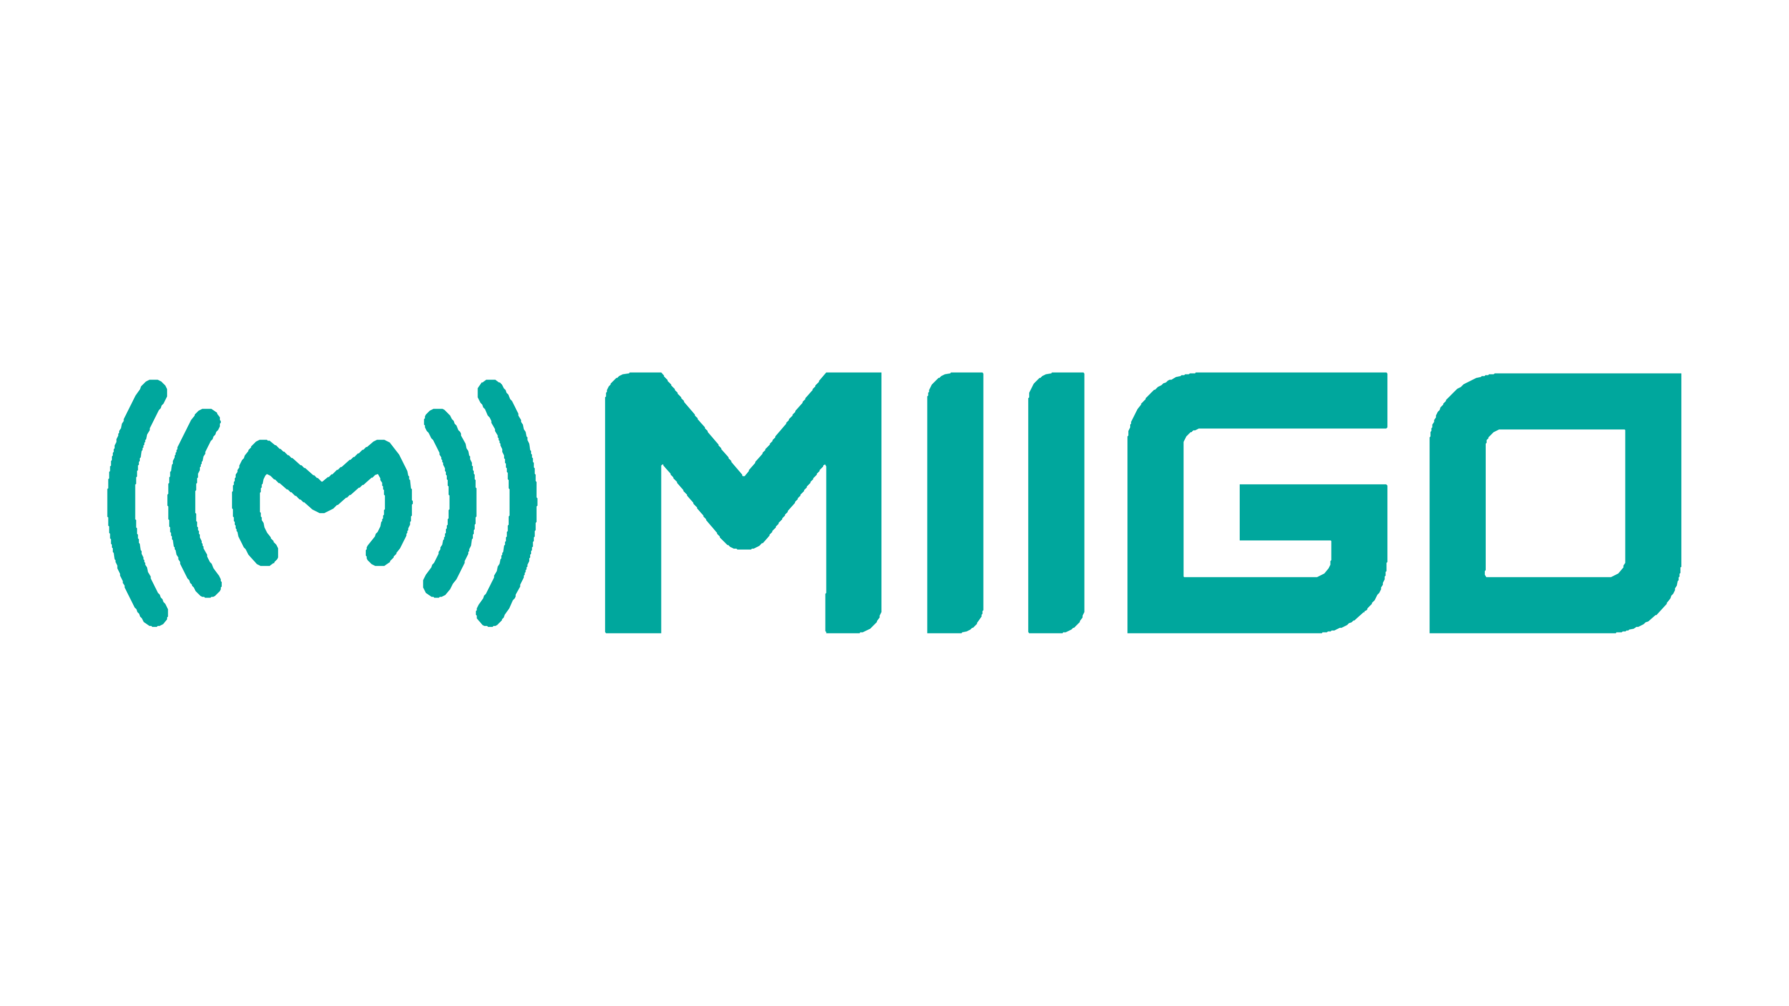
MIIGO ONLINE LLP · MADE IN BHARAT · HYDERABAD

An Invitation to Four Founding Partners
MIIGO ONLINE LLP is forming a Digital Marketing Division. Its first mandate is to take Made-in-Bharat precision instrumentation to roughly 195 countries. Its second is to sell that same capability to MIIGO's dealers and to other customers outside the group. We are looking for four people to build it with us and to own half the profit it makes.
Opportunity | Founding partner, MIIGO Digital Marketing Division
Seats | Four, extendable to six — with additional team added in future based on projects and work load
Basis | Partnership with profit-share — not employment
Partner group share | 50% of Division net profit, divided by involvement
Capital required from you | None. MIIGO funds the entire Year-1 cost base
Benefits to each partner | ₹10,000 per month per partner, drawn against future profit-share, plus shared accommodation provided by the company
Location | Pocharam, Hyderabad — relocation from the agreement stage only
Commitment | A long-term association — not a fixed term, and not a legal lock-in
Trial engagement | 3–10 working days, remote, unpaid
Applications | CV over WhatsApp, naming the seat you want

This document sets out the opportunity, the work, the money and the risks in full. It runs to some length because a decision of this size should not be made on a summary.
Document MIIGO-DMD-PI-001 Rev 5.0 · 18-Aug-26 · Confidential

Contents
Every section can be read on its own. If you read only three, make them Section 8 (why this is worth doing), Section 15 (what Year 1 actually pays) and Section 25 (what could go wrong).
Right-click and choose Update Field to build the contents list.
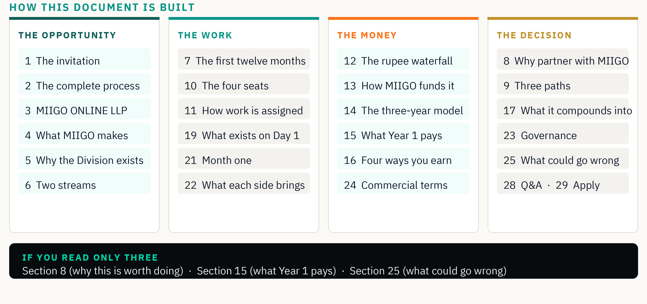
A note on how to read the numbers in this document
Year-1 figures are built from a guaranteed anchor mandate and are close to firm. Year-2 and Year-3 figures are projections modelled from the same waterfall you will find in Section 12. They are stated so you can check the arithmetic yourself, not so you can rely on them as a promise. Nobody at MIIGO can guarantee a future year's profit, and this document does not pretend otherwise.

1. The invitation, in one page
MIIGO ONLINE LLP designs and manufactures precision environmental monitoring instruments in Hyderabad — thermo-hygrometers, data loggers, transmitters, sensors, calibrators and IoT monitoring systems. Nine instrument series and counting, nine accessories and counting, and five software products with more in development. Some instruments are in the market; others are in the process of development. The problem is that the world does not yet know they exist.
Solving that is not a marketing campaign. It is a manufacturing job of a different kind: twenty-three products today and a growing list, each needing a catalogue, a manual, website content, a social kit and film, in several languages, for roughly 195 countries. No agency will do this well, because no agency will learn the category deeply enough to be trusted with a specification value.
So MIIGO is building the capability in-house, as a division, and offering four people — more as the work grows — a founding share of it.

What we are offering
- An anchor mandate of at least ₹30 lakh in Year 1, inclusive of media spend — work that exists on Day 1, with no pitching and no prospecting.
- Fifty per cent of the Division's net profit, shared among the partner pool based on the involvement of each partner, on every project the Division delivers.
- The entire cost base funded by MIIGO for the first year — office, tools, accommodation, admin and audit. No partner contributes capital.
- A ₹10,000 monthly advance from Day 1, drawn against your future profit-share.
- A built-in second market: MIIGO's dealers, who will already trust the brand and already need exactly this work.
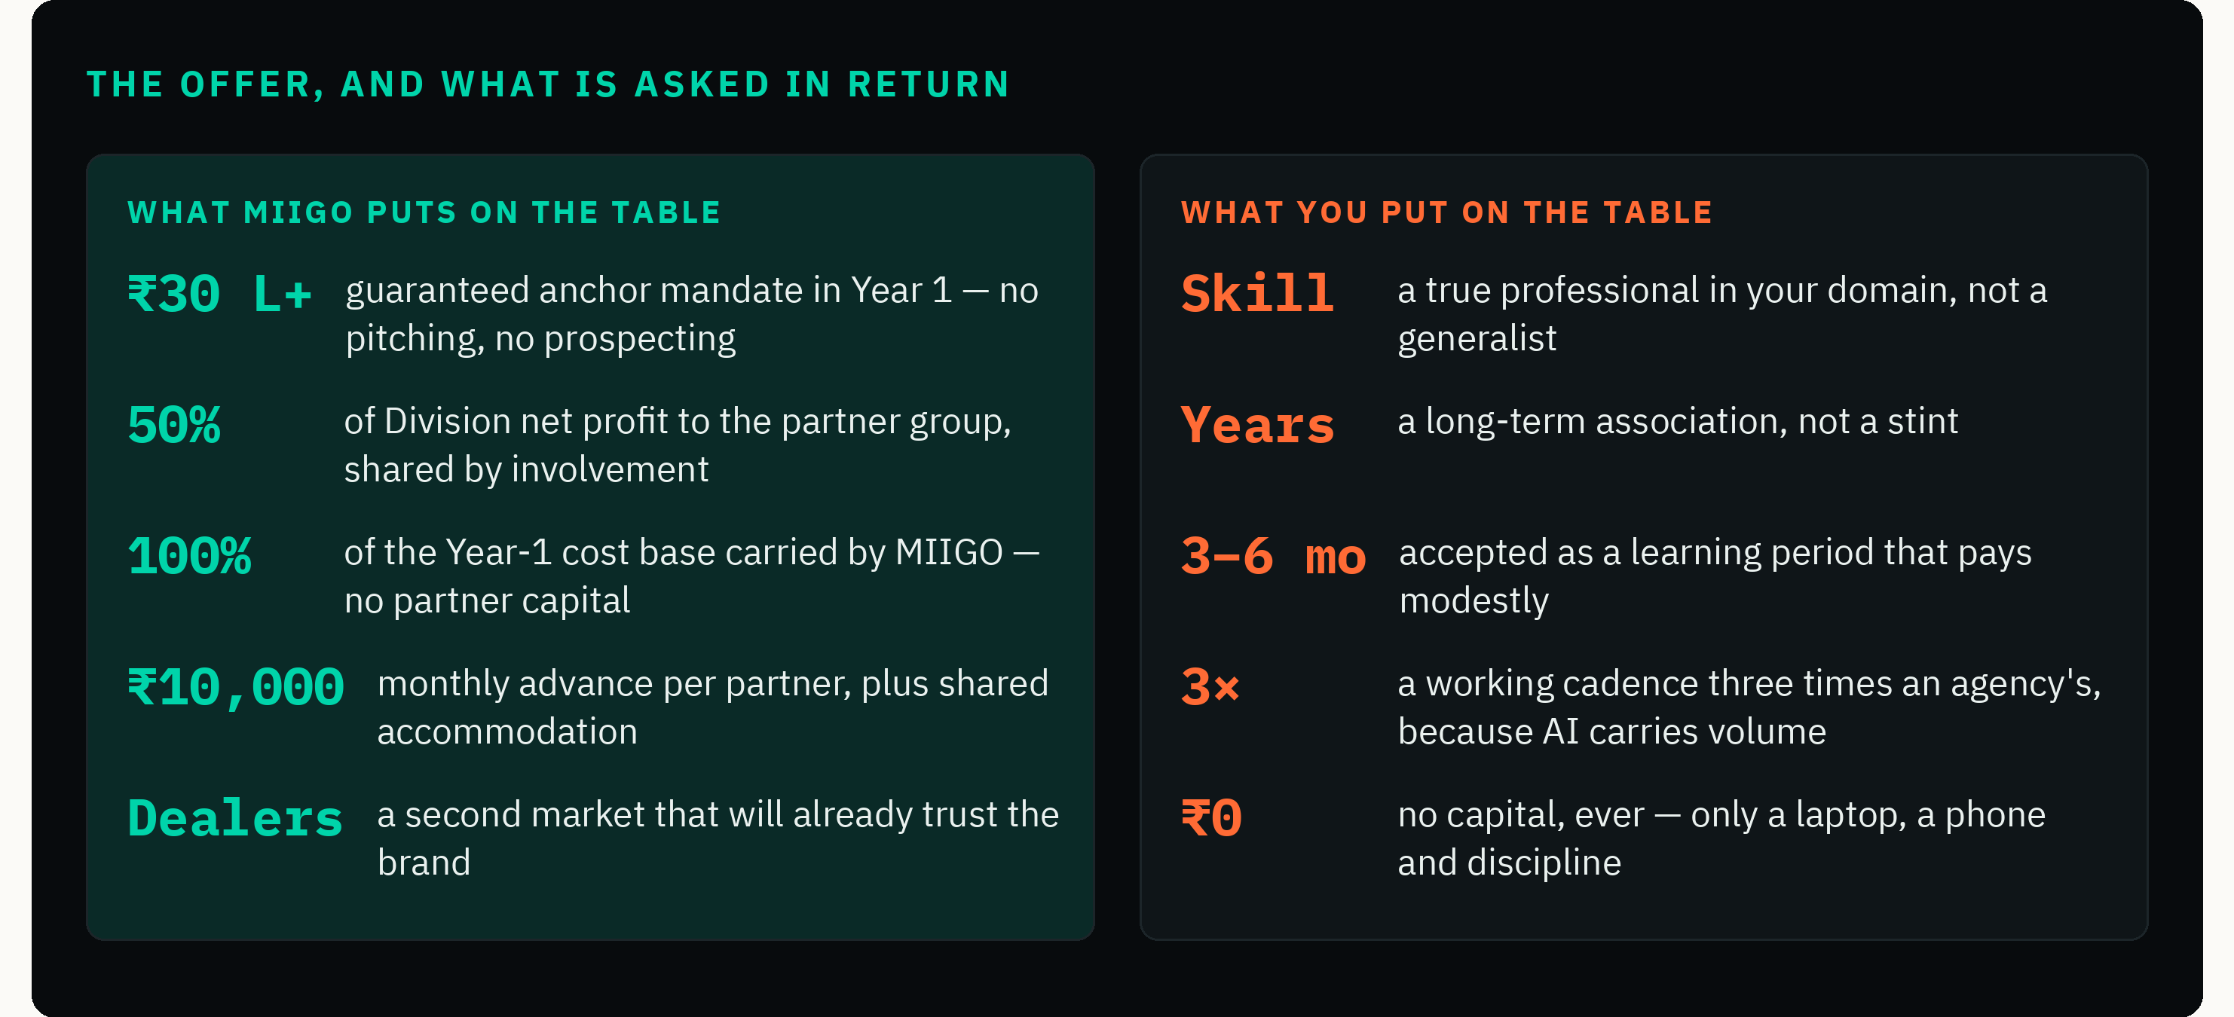

What we are asking for
- Relocation to Hyderabad from the agreement stage, and a long-term association rather than a stint.
- Acceptance that the first three to six months is a learning period that pays modestly — the case rests on Year 2 onwards.
- Work at roughly three times a conventional agency cadence, because AI carries the volume.
- Absolute discipline on accuracy. A fabricated specification is the one unforgivable error in this business.

Who this is for, and who it is not for
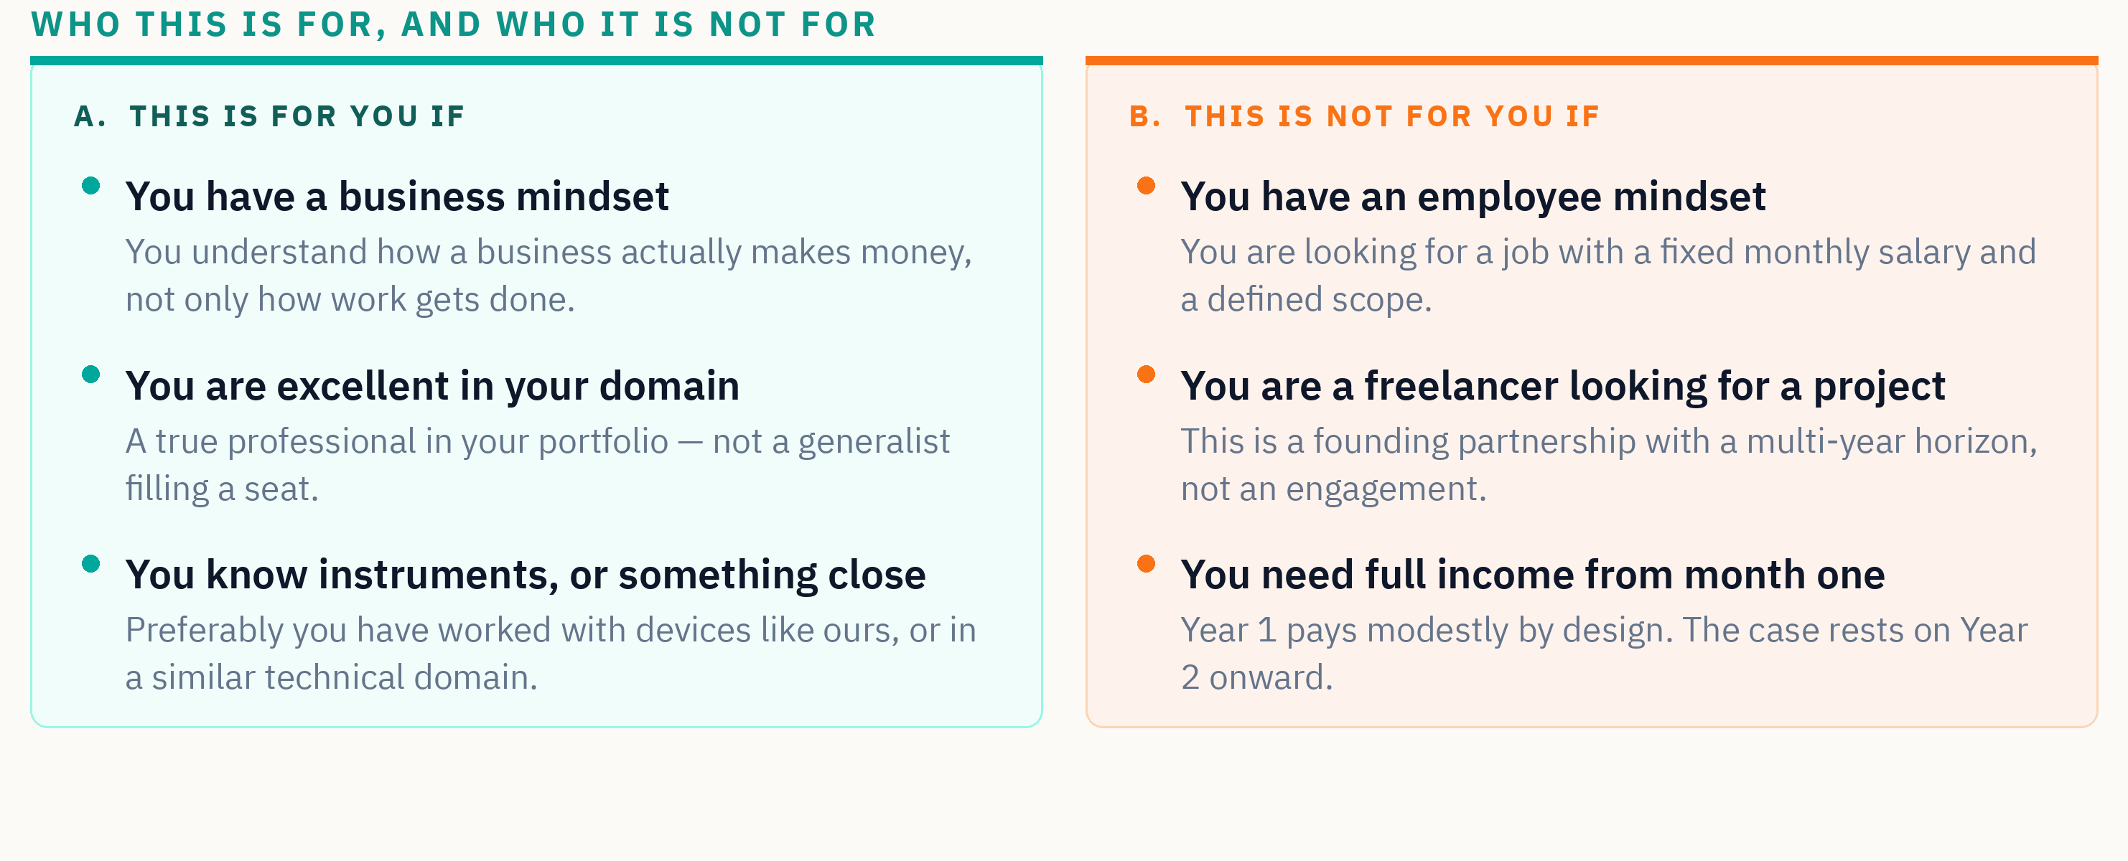
We would rather lose a candidate on page four than in month four. If column B describes you, there is no hard feeling in either direction — it simply means this is not your opportunity, and knowing that now saves us both a great deal.

2. The complete process, on one page
From the moment you send a CV to the moment money reaches your account. Everything in this document is an expansion of one of these five stages.
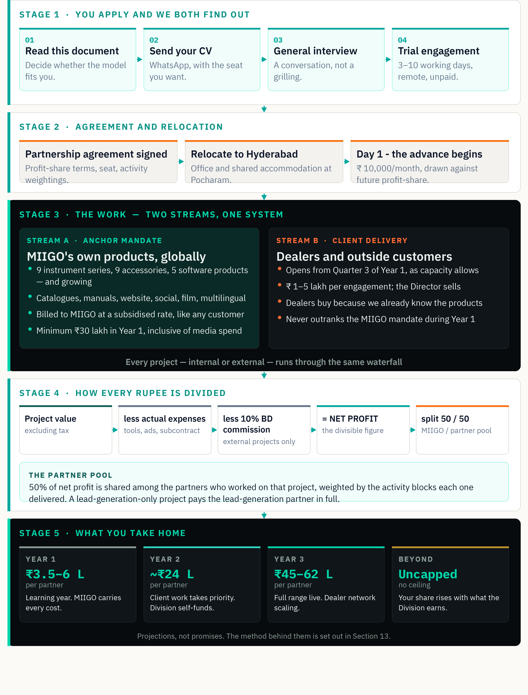

3. MIIGO ONLINE LLP
MIIGO ONLINE LLP is a Hyderabad-based manufacturer of AI-enabled precision environmental monitoring instruments. The company designs and builds its own hardware and writes its own software, under the MADE IN BHARAT mark.
The company is led by its Founder and Director, who brings twenty-three years of experience in technical sales, calibration and instrumentation. You would be partnering with an operating manufacturer that has products in hand and a dealer network being built market by market — not with a concept looking for a team.

Why a manufacturer is building a marketing division
Two reasons, and the second is the interesting one.
The first is necessity. Precision instrumentation is a category where a wrong number in a catalogue is not a typo — it is a liability. Outside agencies do not carry that discipline because they do not carry the consequence. Building the capability inside the company is the only way to hold the standard.
The second is that once the capability exists and has been proven on MIIGO's own range, it is worth money to other people. MIIGO's dealers need exactly this work in their own markets. So do other manufacturers. A division built to solve MIIGO's problem becomes a business in its own right — and that is the part the four partners share in.
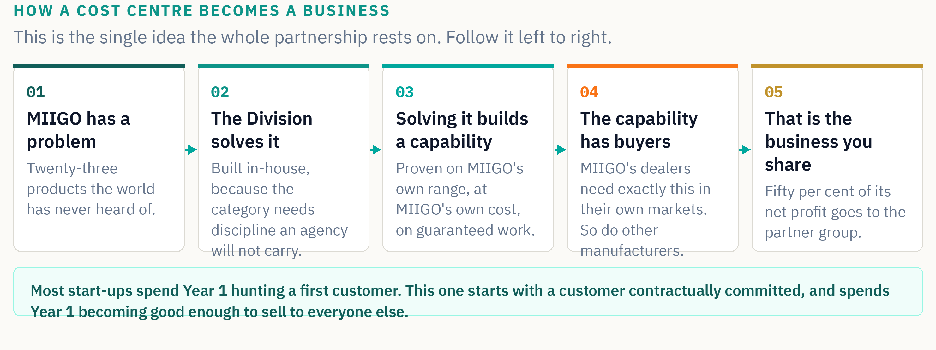

4. What MIIGO manufactures
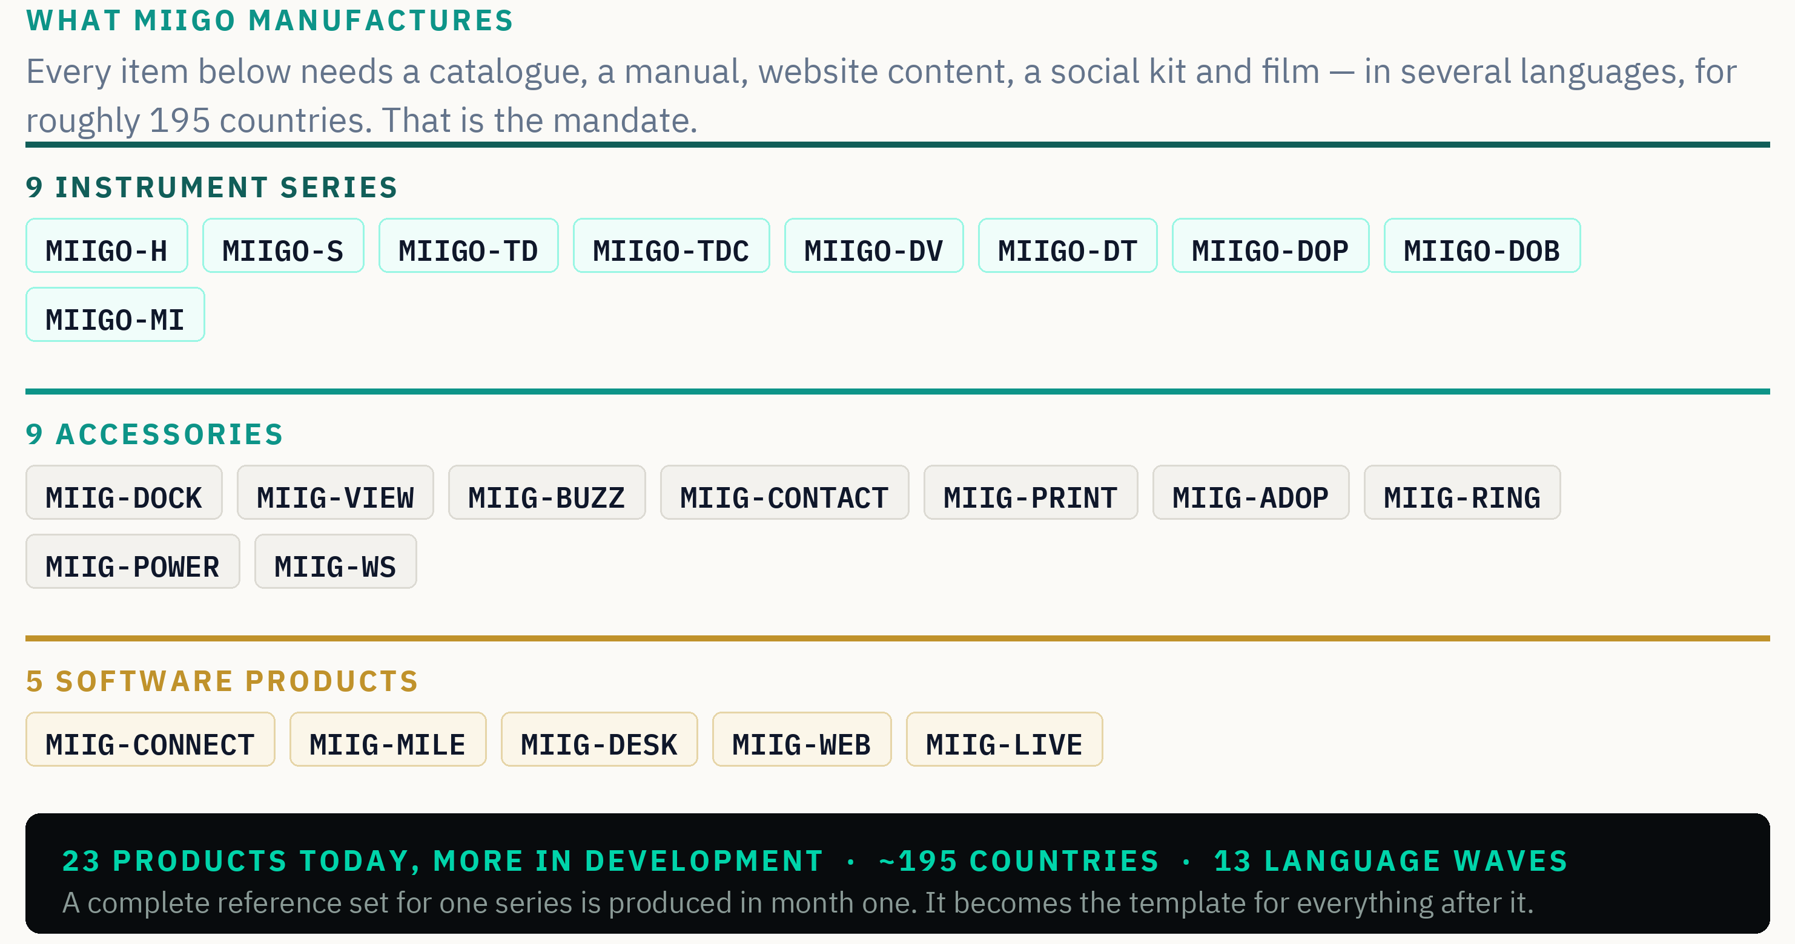
Naming is fixed and is not negotiable in any document the Division produces: MIIGO- denotes an instrument series, MIIG- denotes an accessory or a software product. The two forms are never normalised to one. MADE IN BHARAT is set in capitals, always.
A recent reclassification
The weather station has been reclassified from MIIGO-WS to MIIG-WS and now sits with the accessories rather than the instrument series. The counts above reflect that change: nine instrument series, nine accessories, five software products. The list is growing, and any figure in this document is the position on the date of issue.

5. Why the Digital Marketing Division exists
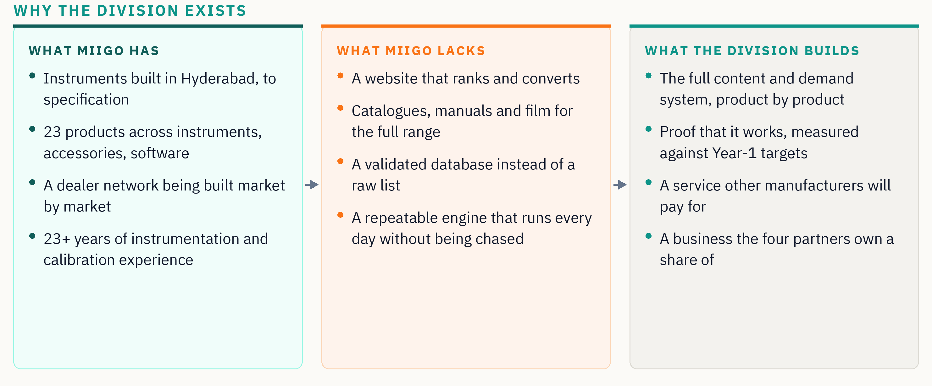
The Division exists to close the middle column. Everything else in this document — the seats, the money, the governance — is machinery built around that single job.

The gap, stated as numbers
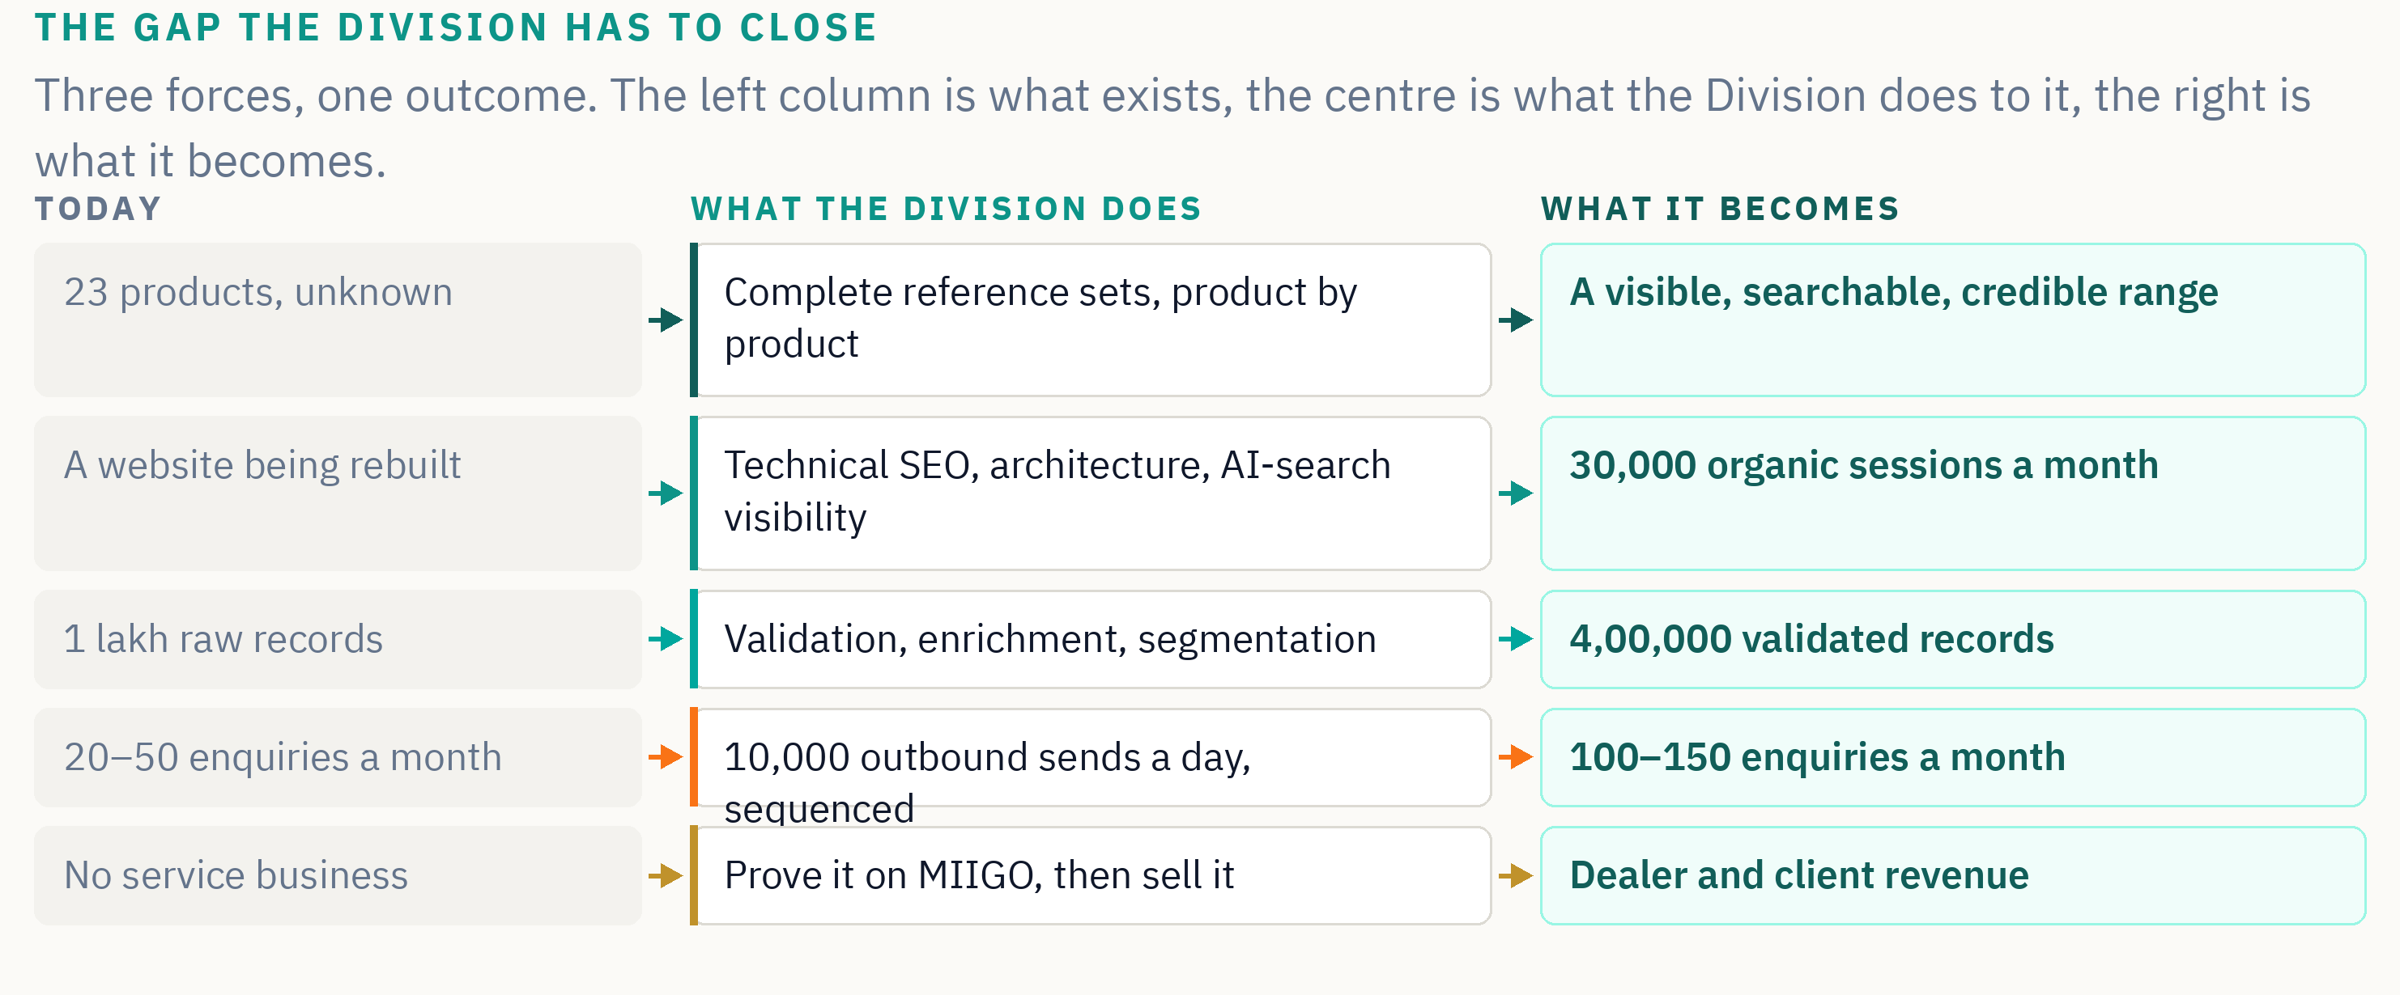

6. How the Division works: two streams
The Division runs two streams of work at once. They move at different speeds, and understanding the difference is the key to understanding the money.

Stream A — the MIIGO anchor mandate
MIIGO's own products, taken to market globally. Catalogues, manuals, website, social, film, multilingual, across the full range of twenty-three products and roughly 195 markets in thirteen language waves.
Critically, MIIGO does not simply hand this work to the Division. MIIGO is billed for it, like any other customer, at a rate agreed in the partners' meeting. That rate is subsidised — below what an outside client would pay — in exchange for MIIGO carrying the entire cost base of the Division in Year 1. It is stated here rather than discovered later, because the size of that subsidy directly affects what partners earn on internal work.
Stream A carries a minimum value of ₹30 lakh in Year 1. That figure is a floor, not a forecast — but it is important to understand exactly what it contains.
The ₹30 lakh is inclusive of media spend
Advertising and paid promotion sit inside the ₹30 lakh, not on top of it. Media is a pass-through cost, so it comes off as an actual expense before profit is divided. The share of the mandate given to media is set in the partners' meeting, which means it directly affects what partners earn — and it is why Section 15 shows Year-1 income across three media cases rather than as a single number.

Stream B — dealers and outside customers
Client delivery: website builds and maintenance, CRM services, content production, demand generation and lead intelligence, sold to MIIGO's dealers and to manufacturers outside the group. Engagements run at ₹1–5 lakh each. The Director sells; partners deliver.
MIIGO's dealers are the natural first market. They already trust the brand, they already sell the products, and the Division already owns the assets and the category knowledge. Localising a MIIGO catalogue or a MIIGO product film for a dealer's market costs a fraction of what an outside agency would charge simply to learn the category first. That is the value addition, and it is why we expect dealers to be the easiest engagements the Division ever wins.
One waterfall, no special cases
Because MIIGO bills itself like any other customer, internal work and client work run through exactly the same profit waterfall. There is no separate rule for MIIGO's own projects, no portfolio that earns nothing because its work happens to be internal, and no argument to be had about which bucket a piece of work falls into.

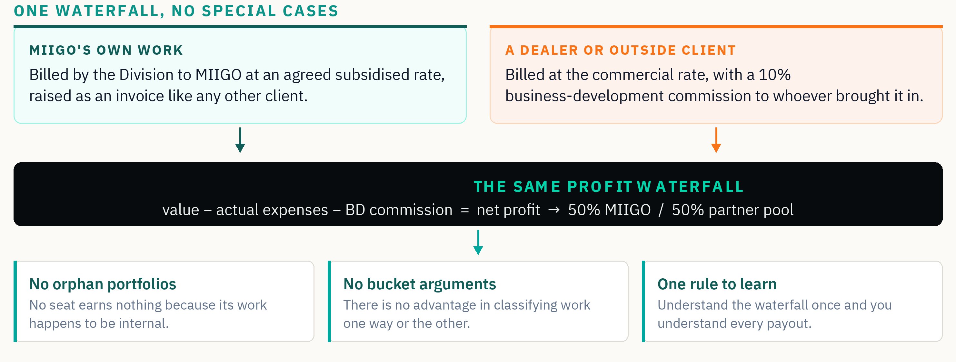

7. The first twelve months
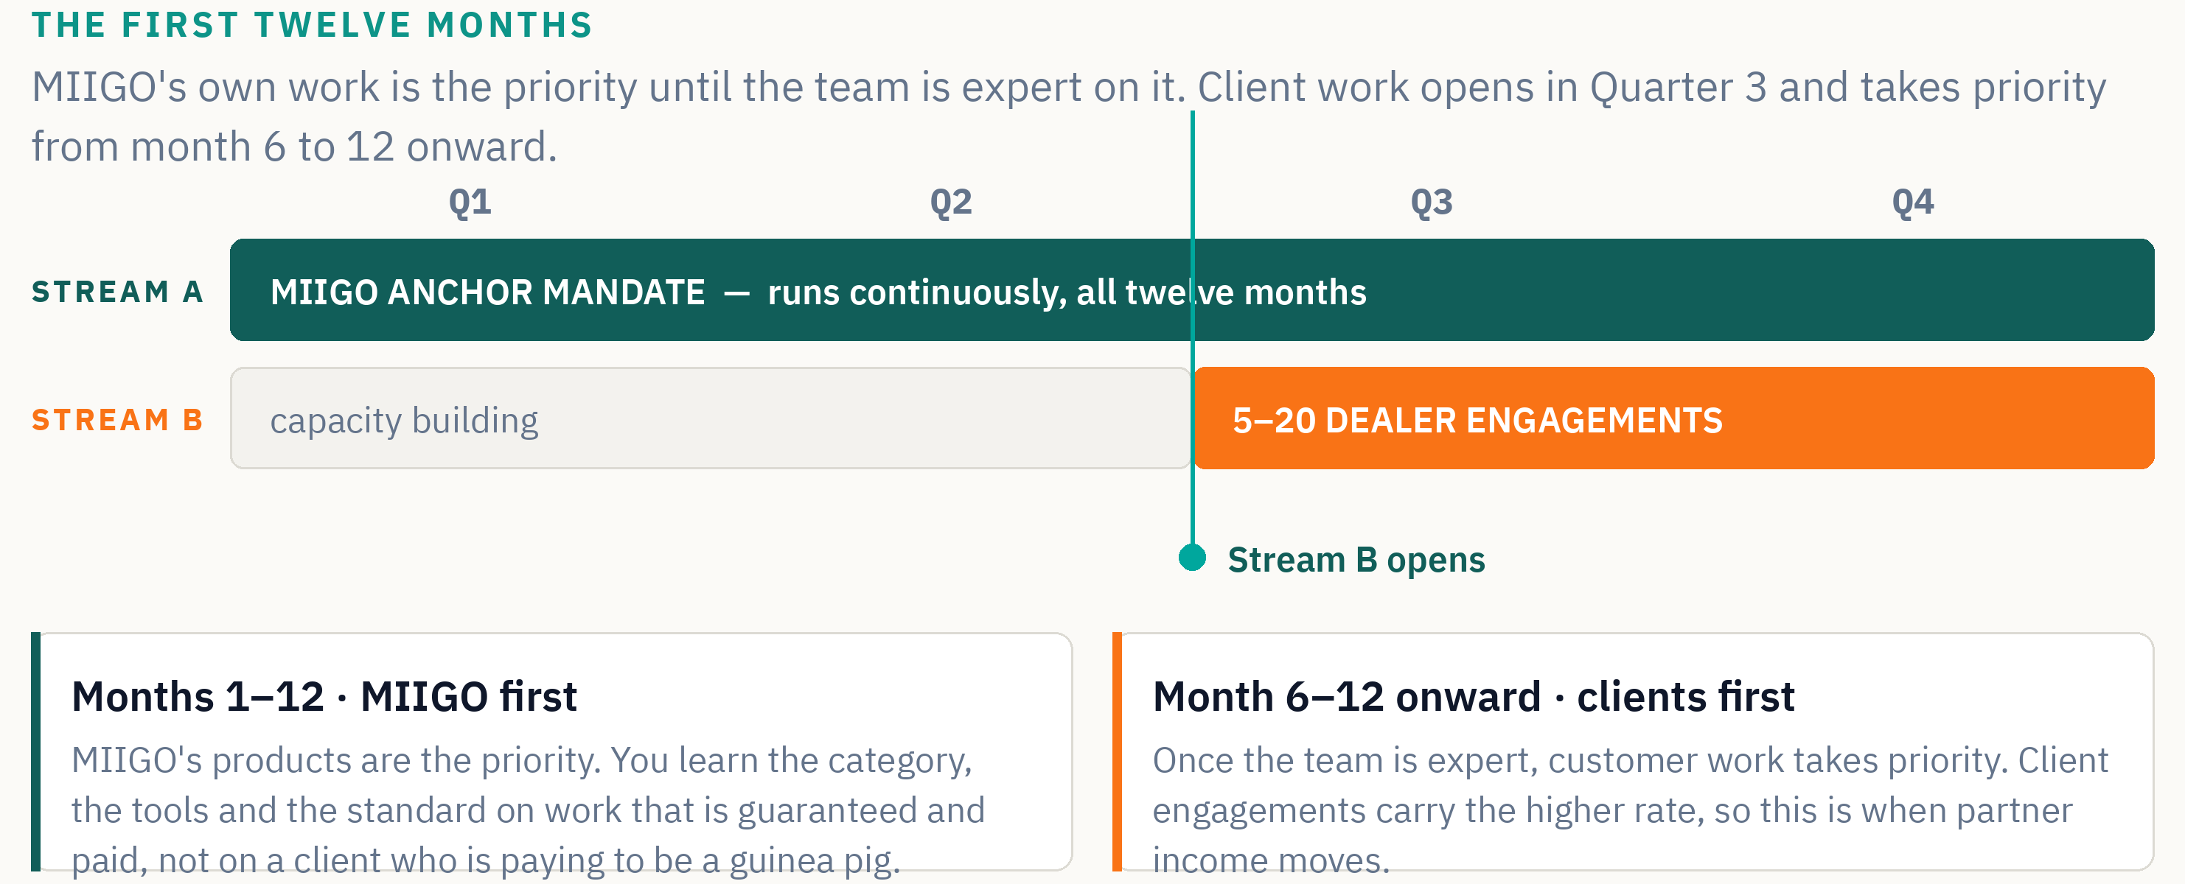
The priority rule is one sentence and it does not move: for the whole of Year 1, MIIGO's own work comes first. Stream B opens in Quarter 3 as capacity allows, but it never outranks the anchor mandate during the first twelve months.
That is in your favour, not against you. It means you learn the category, the tools and the standard on work that is committed and paid, rather than on a client who is paying to be your training ground. From Year 2, once the team is expert and the Division funds itself, client work moves to the front — and client engagements carry the higher rate, which is when partner income moves.
Stream B is expected to open in Quarter 3 with somewhere between five and twenty dealer engagements. The actual number depends entirely on how well the Division performs in the first two quarters. That is stated as a target, not a commitment.

8. Why partner with MIIGO
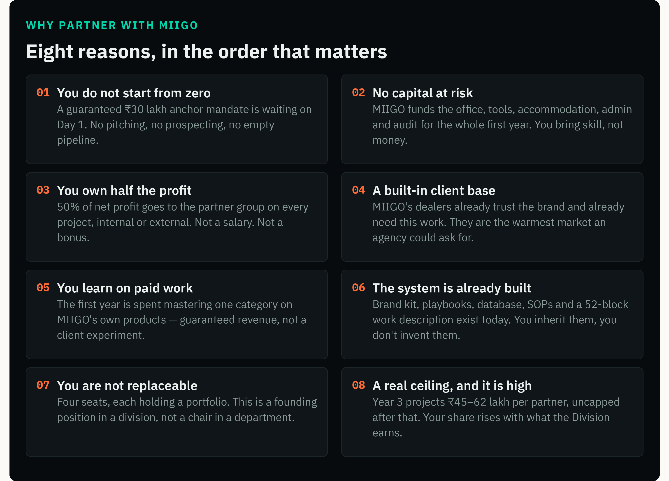

The argument in one paragraph
Most people who want to build something for themselves face the same wall: they can either take a salary and build nothing, or risk their own capital and spend a year looking for the first client. This offer removes both horns. The capital is MIIGO's. The first client already exists and is contractually committed. What you contribute is skill and time, and what you get in return is half the profit of the business you build with it.
That is an unusual trade, and it is worth being honest about why MIIGO can offer it: because MIIGO needs this capability to exist regardless. The Division is not a speculative venture looking for a market. It has a market on Day 1, and that market is us.

9. Three paths, compared
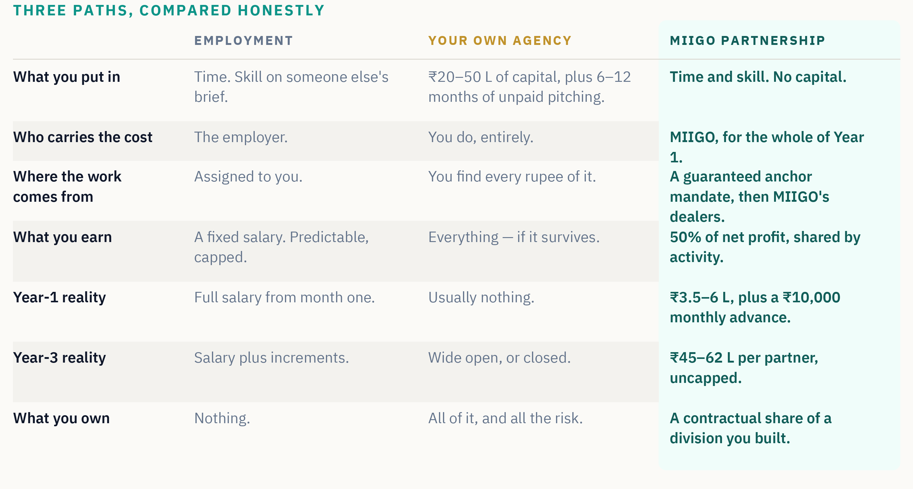
The comparison is not meant to make employment look foolish. A salary is a real thing and for many people at many stages it is the right answer. The point is narrower: if you were going to back yourself anyway, this route removes the two costs that usually sink that decision — the capital and the empty pipeline.
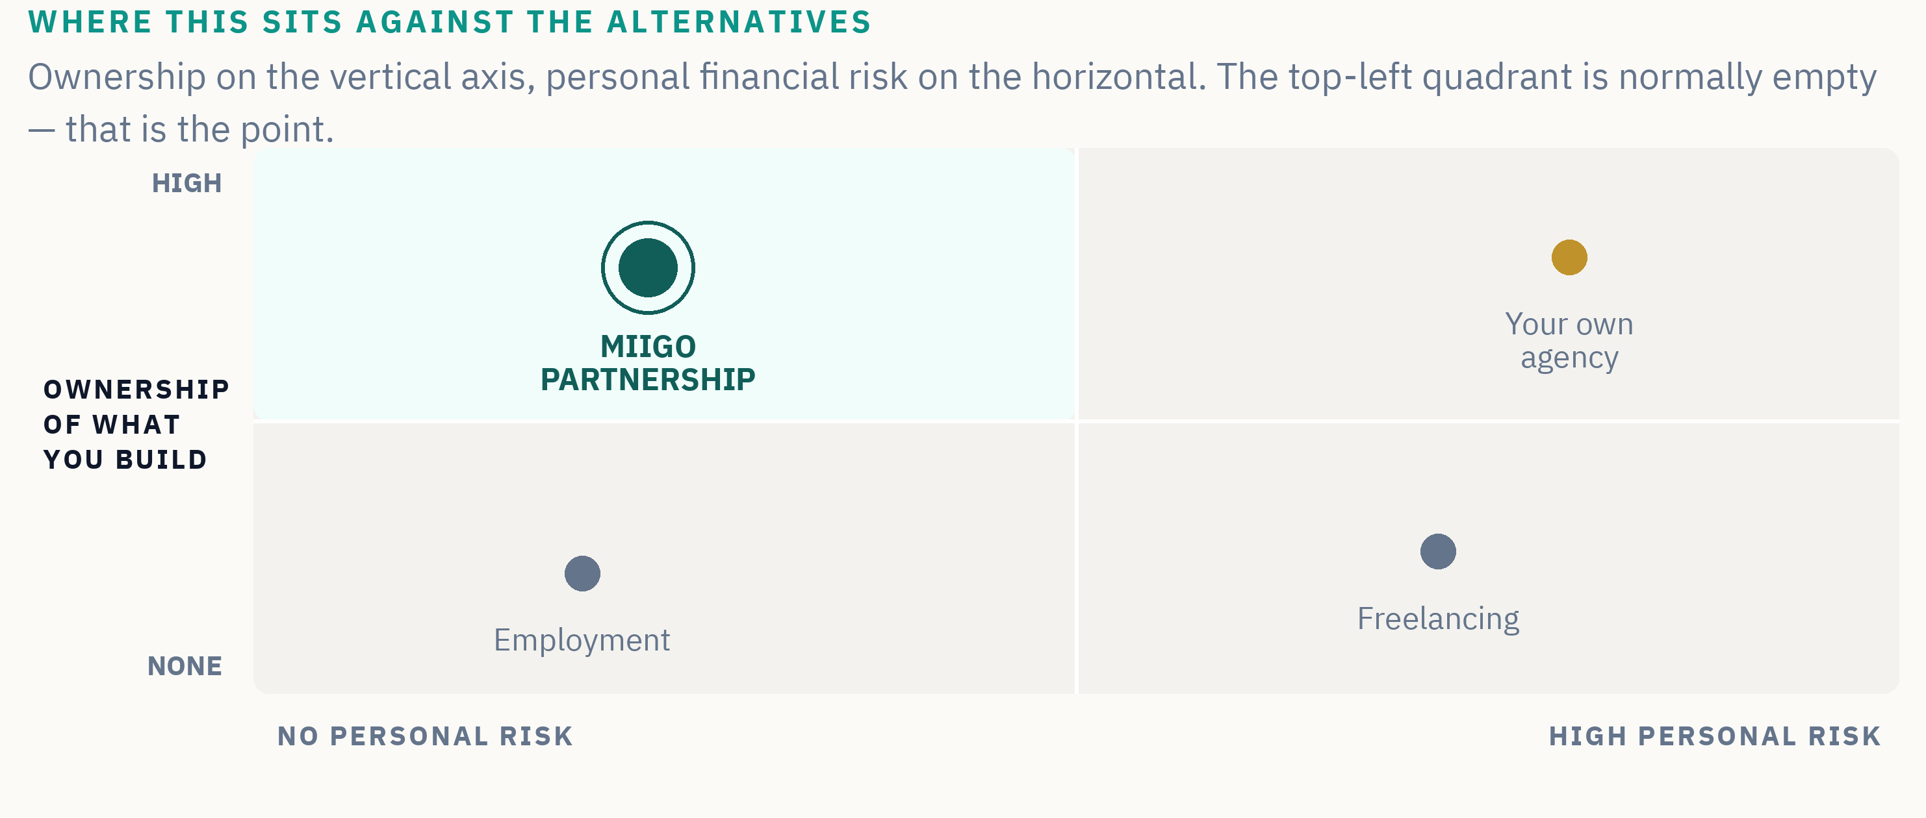

10. The four partner seats
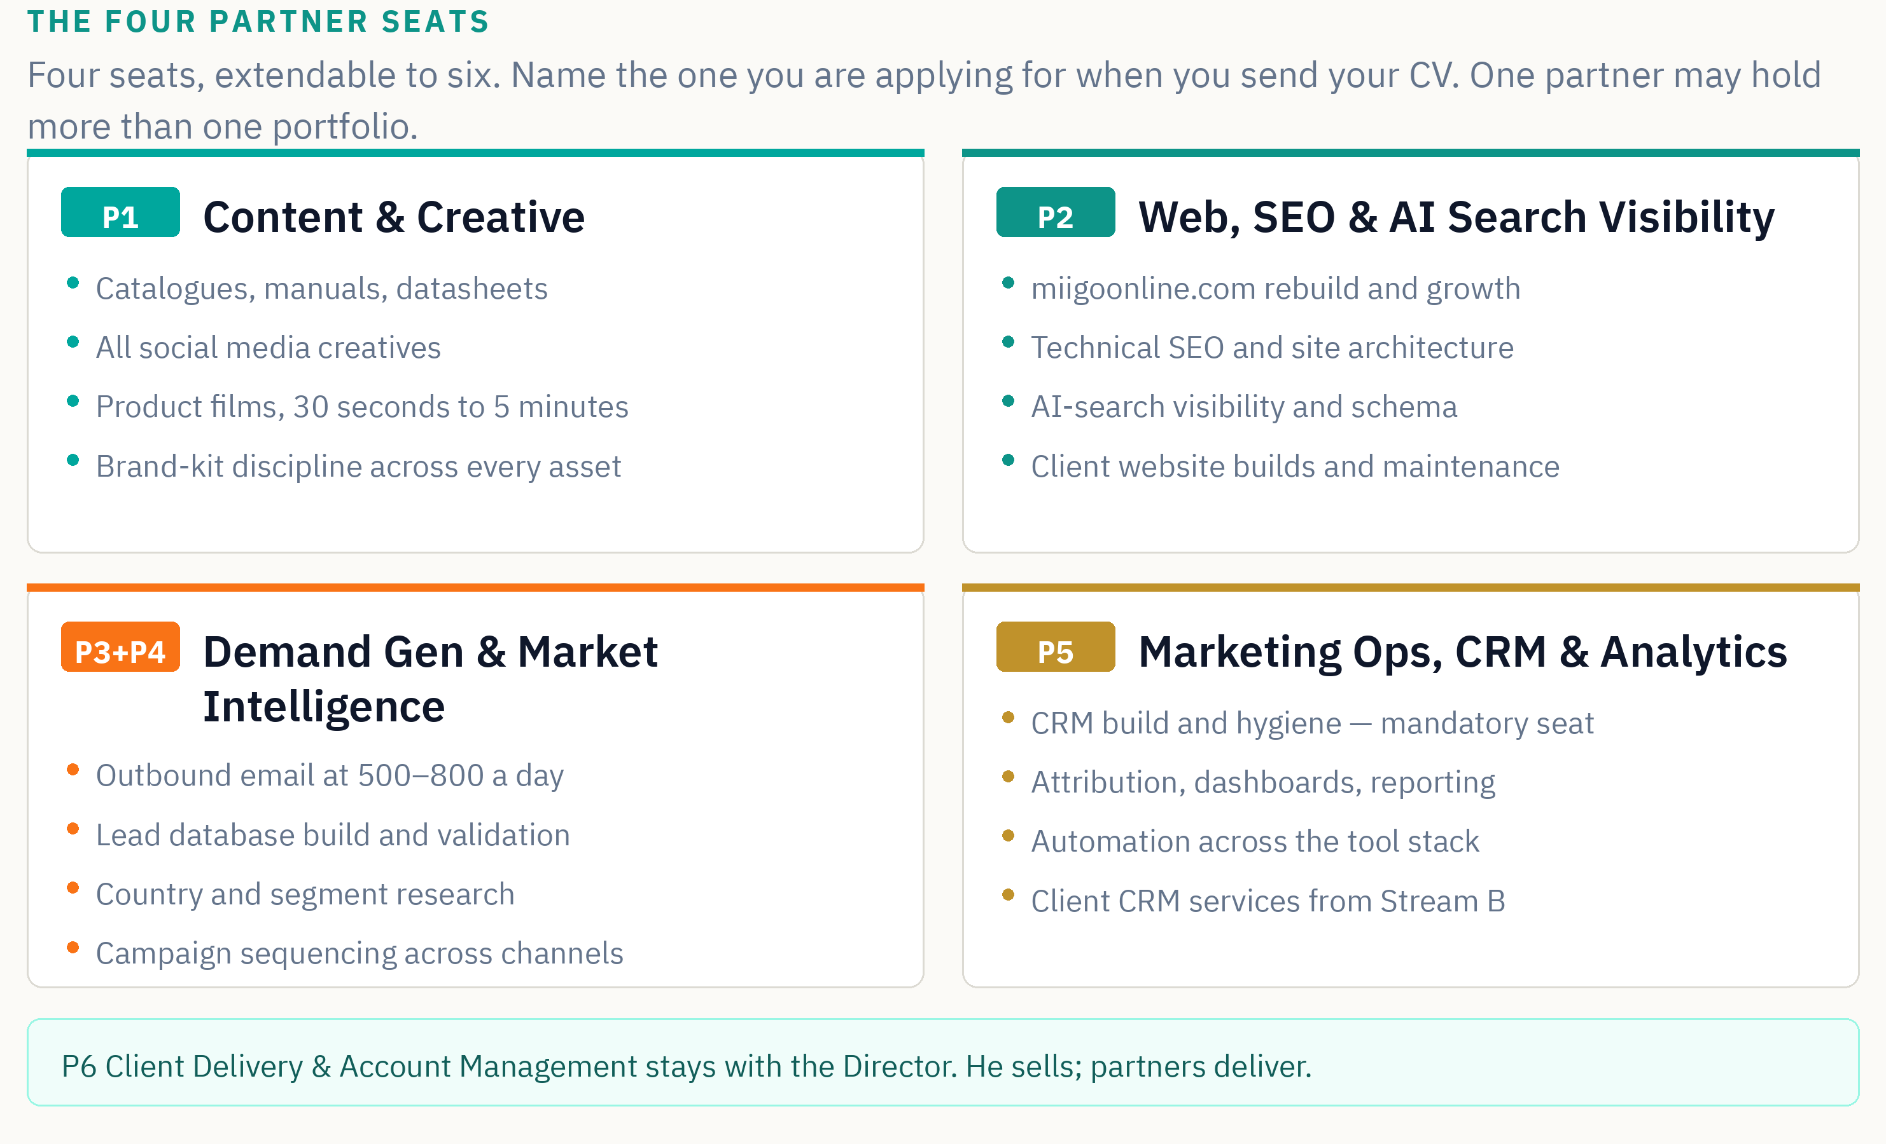
Name the seat you are applying for when you send your CV. If you are strong across two, say so — one partner may hold more than one portfolio, and the weighting of your profit-share reflects the scope you carry.
Marketing Operations, CRM and Analytics is described as mandatory, and that word means two specific things. First, every applicant must be able to support it alongside their own seat — CRM hygiene, clean data and honest attribution are a shared discipline, not one person's chore. Second, the Director holds the P5 portfolio himself until the right partner is found for it, so the function is never unstaffed.
The reason is simple: without clean data and working attribution nothing the Division does can be measured, and a division that cannot be measured cannot be sold as a service to anyone.

11. How work is assigned
Work is not assigned by job title. The Division's Work Description sets out six portfolios broken into fifty-two numbered activity blocks. Each block is a discrete unit of work — for example, technical SEO for a product page, or a thirty-second product film, or the validation pass on a country segment of the lead database.
Blocks are assigned to partners by capability, not by seat boundary. Each block carries a pre-agreed weighting, and when a project completes, the partner pool for that project is split according to the blocks each partner delivered. The final split is confirmed in the partners' meeting.

Why it is done this way
Two reasons. First, it means a partner who takes on more scope earns more, without needing to renegotiate anything. Second, it means the rule is known before the work starts, so the conversation at the end is about which blocks were delivered — a question of fact — rather than about what someone's contribution felt like.
Worked example | Blocks delivered | Share of the pool
A dealer buys lead-generation only | Demand generation and database blocks only | One partner takes the pool in full
A dealer buys a website and CRM | Web/SEO blocks plus operations and CRM blocks | Split between two partners by weighting
A dealer buys a full launch package | Content, web, demand generation and operations blocks | Split across all four, by weighting

12. How every rupee is divided
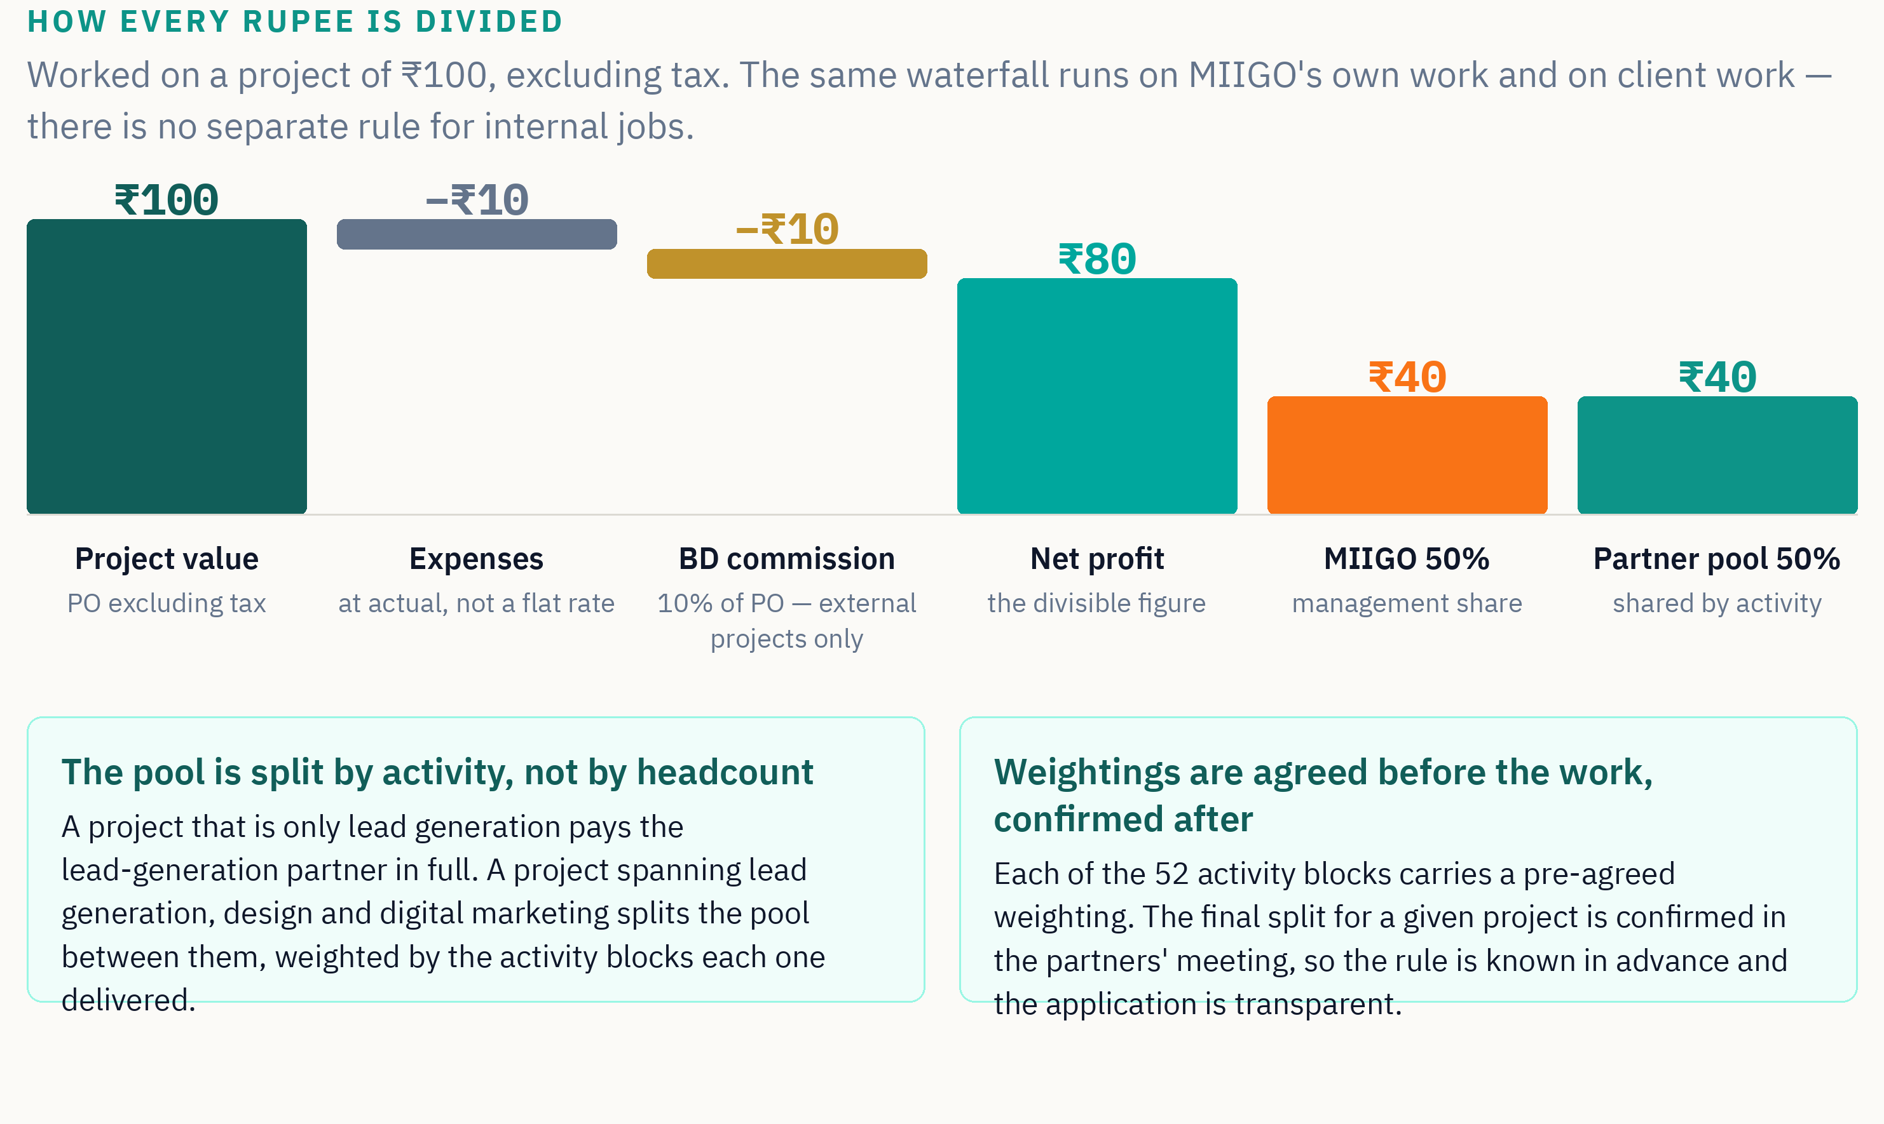

Three details that matter
- Expenses are deducted at actual, not as a flat percentage. What the project genuinely cost comes off; nothing more.
- The 10% business-development commission applies to external projects only. It does not apply to MIIGO's own work, because there is no business development involved. On external projects the Director currently takes it, since he holds the client-facing portfolio and sells the work himself. That is stated plainly so it is never a surprise.
- Principal repayment of MIIGO's funding is a balance-sheet movement, not an expense. It never reduces the profit that partners share. Only the interest is charged.

When you are paid
For MIIGO's own projects, profit is declared quarterly. For client projects, the partner pool for a project is released once the customer has paid. The Division will operate a monthly or quarterly payout rhythm, decided in the partners' meeting, so that income is regular rather than lumpy.
If a customer never pays, that revenue simply never enters the pool. Nobody is charged for it and nobody earns from it. MIIGO carries the Division's operating losses; partners are never asked to underwrite a client's credit risk.

13. How MIIGO funds the Division
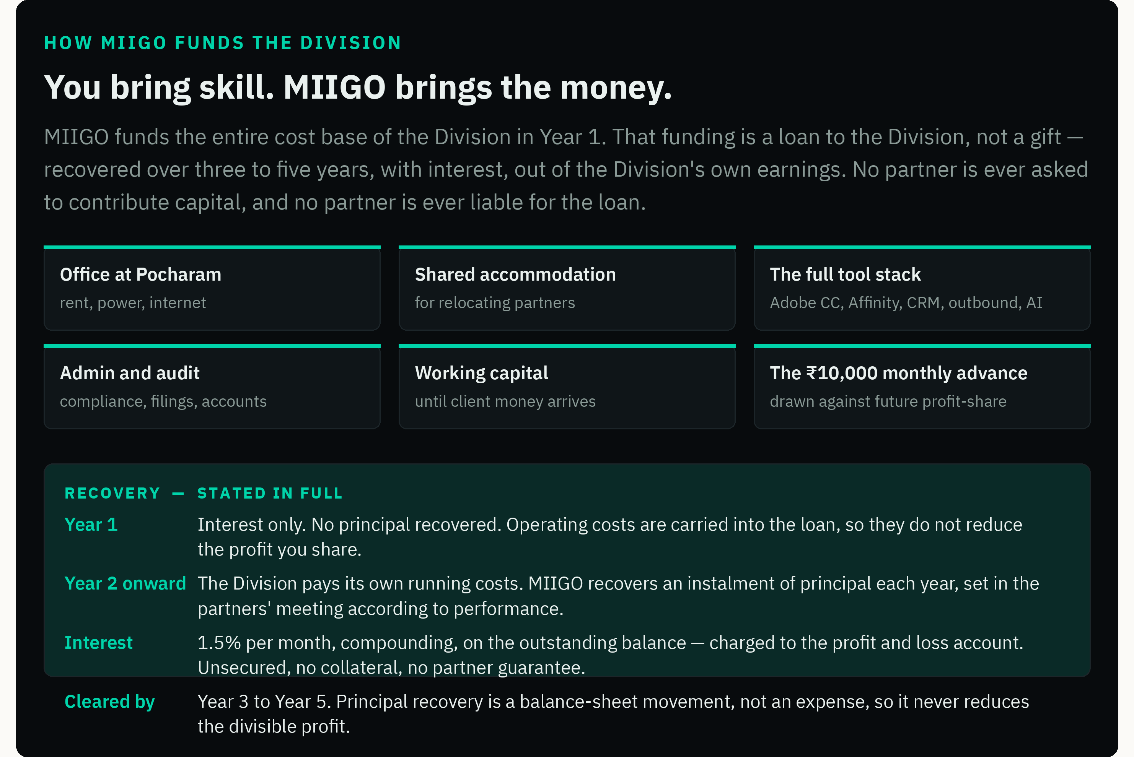

Why the interest rate is what it is
One and a half per cent a month compounds to roughly 19.6% a year. That is above a commercial bank rate, and the reason is worth stating: this is unsecured funding with no collateral, no covenants, no personal guarantee from any partner and no recourse if the Division fails. A bank would not write it at any rate. MIIGO is writing it because MIIGO needs the Division to exist.
Over the life of the loan the total interest is expected to land near ₹9 lakh, of which the partner pool bears half — roughly ₹27,000 per partner per year. It is a real cost and it is disclosed here rather than buried.

If a partner wants to invest
No partner is required to put in money, and no partner is disadvantaged for not doing so. A partner who wishes to lend money to the Division may do so at the same rate MIIGO charges. Because partners hold a contractual profit-share rather than equity in the LLP, such lending has compliance implications, and any arrangement of this kind will be cleared with the company's chartered accountant before it is entered into.

14. The three-year model
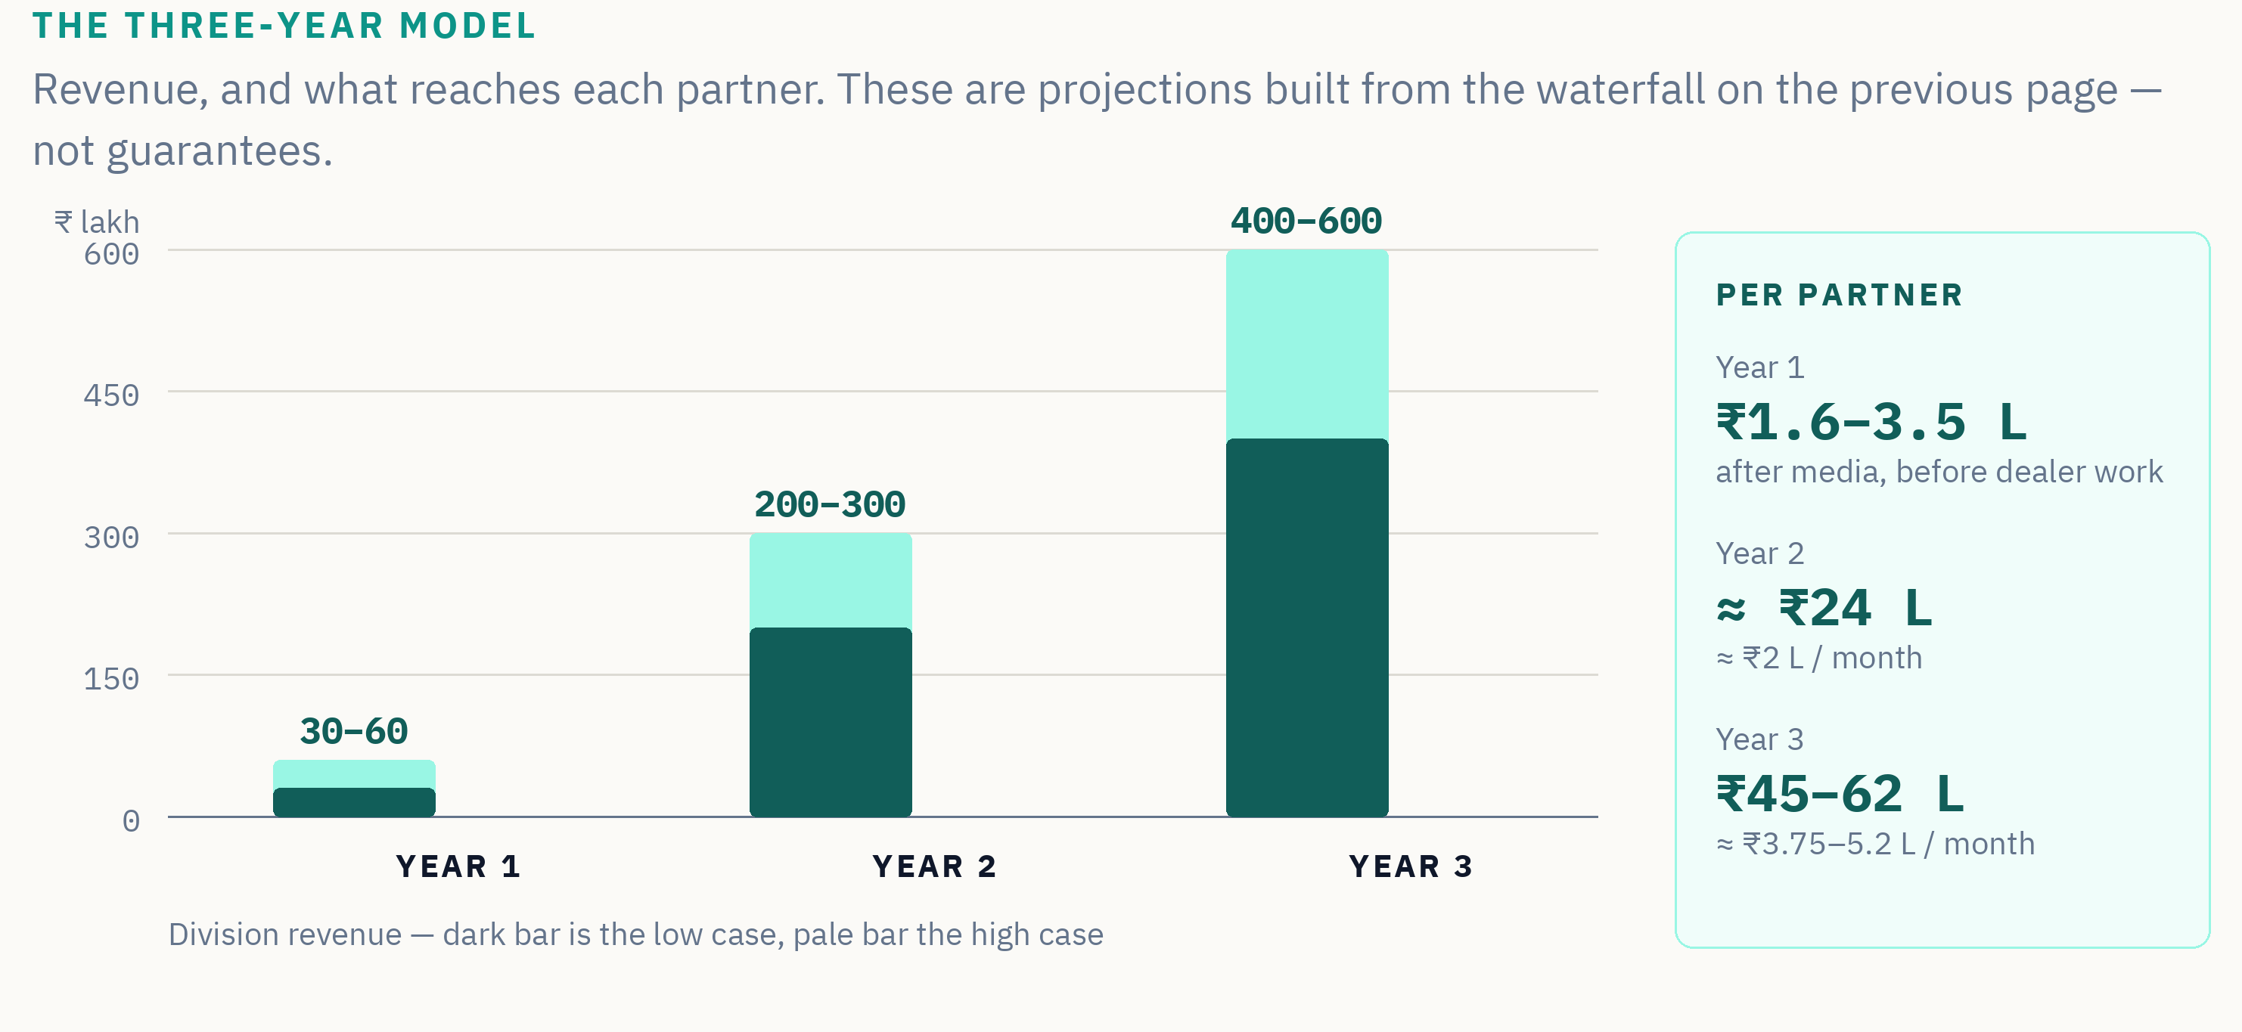
 | Year 1 | Year 2 | Year 3
Division revenue — minimum | ₹30 lakh (anchor mandate, incl. media) | — | —
Division revenue — base case | ₹40 lakh | ₹2 crore | ₹4 crore
Division revenue — target | ₹50 lakh | ₹2.5 crore | ₹5 crore
Division revenue — upside | ₹60 lakh | ₹3 crore | ₹6 crore
Operating costs | Funded by MIIGO, carried into the loan | Paid by the Division from its own revenue | Paid by the Division
Loan position | Building to roughly ₹20 lakh | Recovery begins | Reducing toward nil
Partner pool | ₹6.5–14 lakh | approx. ₹98 lakh | ₹1.8–2.5 crore
Per partner | ₹1.6–3.5 lakh | approx. ₹24 lakh | ₹45–62 lakh
Delivery capacity | Four partners | Four partners, selective support | Bench partners, junior staff or freelancers added on requirement

Year-1 figures are stated four ways deliberately. The minimum is the anchor mandate alone, inclusive of media and therefore the floor. The base case assumes modest dealer work from Quarter 3. The target is the number the Division is being asked to hit. The upside assumes dealer work at the top of the 5–20 engagement range. Partner figures follow the same logic; Section 15 shows how media share moves them.
Year-3 delivery is scaled with bench partners, junior staff or freelancers as the work requires — added on requirement and against the work a client has actually given, never as a fixed headcount carried speculatively.

15. What Year 1 actually pays
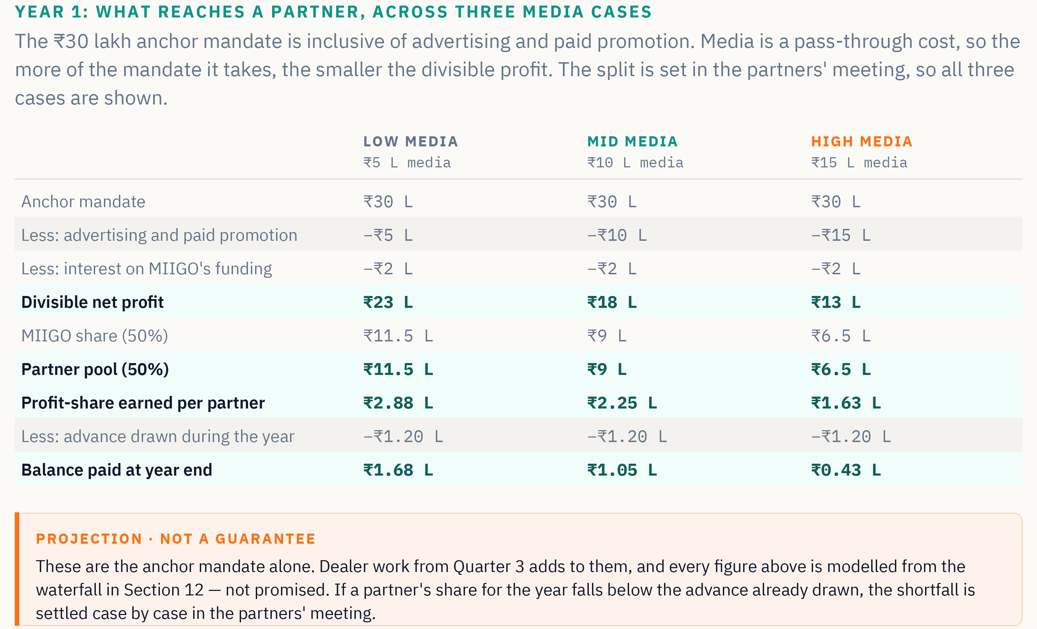
You would have done this arithmetic yourself within a day of receiving this document. We would rather you found that we had done it first.

How to read the table
- The ₹10,000 monthly advance is not extra pay. It is drawn against the same profit-share, which is why it appears as a deduction rather than an addition. The bottom row is what actually reaches you at year end, on top of what you have already received monthly.
- Dealer work from Quarter 3 sits on top of every column. Five to twenty engagements at ₹1–5 lakh each would add materially — but it is a target, not a commitment, so it is excluded from the table rather than assumed into it.
- If your share for the year comes in below the advance already drawn, the shortfall is settled case by case in the partners' meeting. There is no automatic clawback.
Read this before you apply
Year 1 is a learning period and it pays like one. The ₹10,000 monthly advance is what you can count on; everything above it depends on what the Division earns and on how much of the mandate goes to media. The case for this partnership rests on Year 2 and Year 3, not Year 1. If you need a full income from month one, this is not the right move for you.

16. Four ways a partner earns
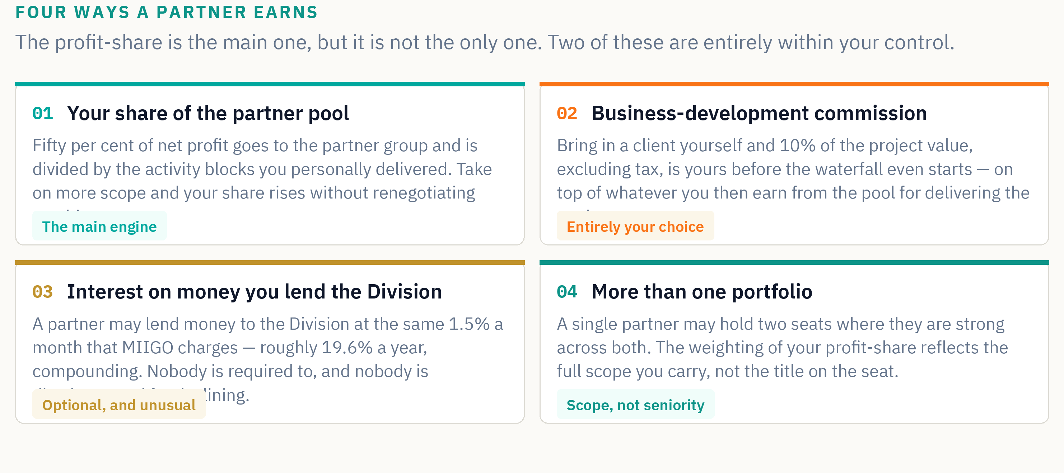
The third of these is worth pausing on, because it is unusual and it is easy to miss. MIIGO charges the Division 1.5% a month on the money it lends — roughly 19.6% a year, compounding. Any partner who has capital sitting idle may lend it to the Division on exactly the same terms and earn exactly the same return. It is entirely optional, nobody is required or expected to, and no partner is disadvantaged in any way for declining. Because partners hold a contractual profit-share rather than equity in the LLP, any such arrangement is cleared with the company's chartered accountant before it is entered into.
The point of the second stream
A partner who brings in a client takes 10% of the project value before the waterfall even starts, and then earns again from the pool for delivering the work. Nobody is required to sell — the Director holds the client-facing portfolio and sells the work himself. But the door is open, and it is open at a rate most agencies would not offer their own sales staff.

17. What this compounds into
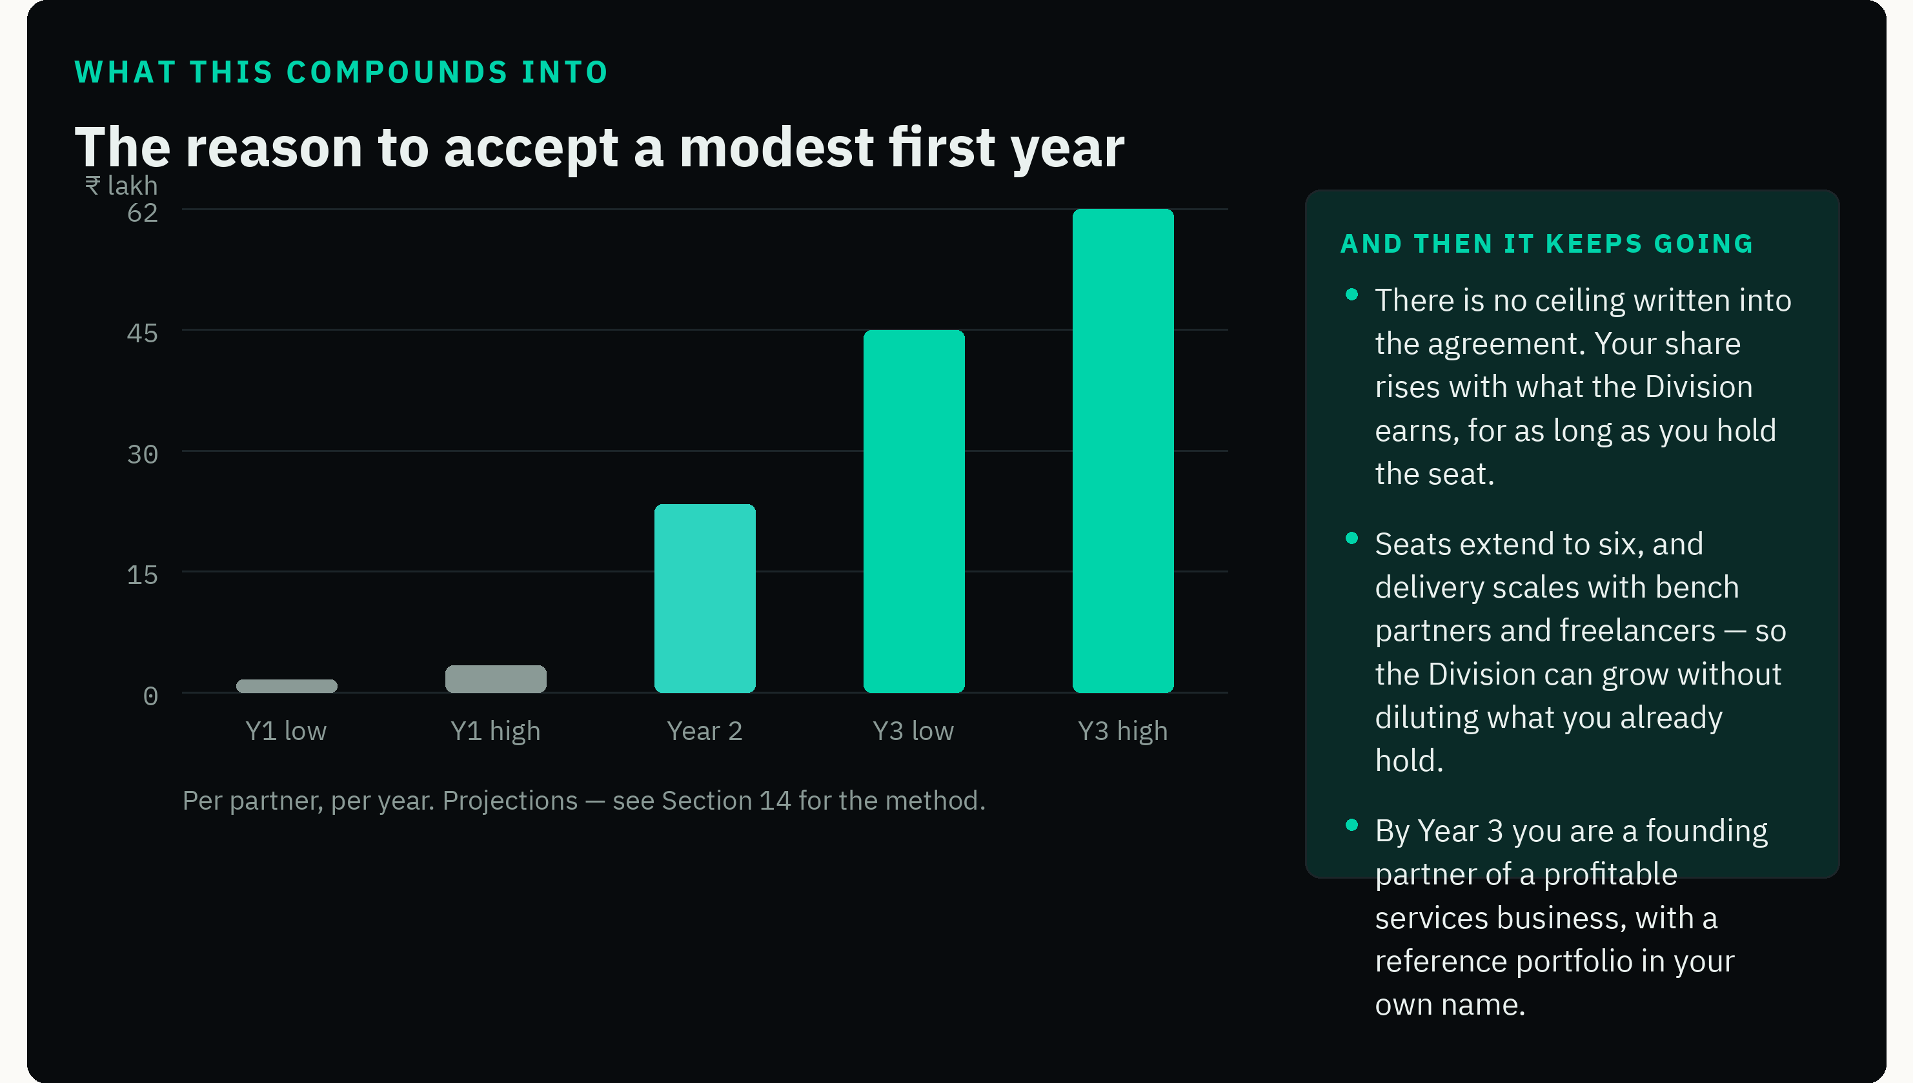
It is worth being blunt about the trade this document is asking you to make. You are being asked to accept three to six months of learning at modest pay, in exchange for a permanent, uncapped share of a business that already has its first customer.
Most people never get offered that trade, because most people who want it have to fund it themselves. The reason MIIGO can offer it is not generosity — it is that MIIGO needs this capability to exist whether or not anyone takes the offer. The Division is going to be built. The only open question is who builds it and who owns a share of the result.

Where a partner stands in five years
- A founding share of a profitable services division, with no ceiling written into the agreement and no dilution as the team grows.
- A reference portfolio in your own name — twenty-three-plus products taken to roughly 195 countries, which is a body of work very few people in this category can claim.
- Deep expertise in a technical niche that does not commoditise, on a range you helped define.
- A seat in the partners' meeting of a business you know from the inside, because you built the system it runs on.

18. Where you start, and where you must get to
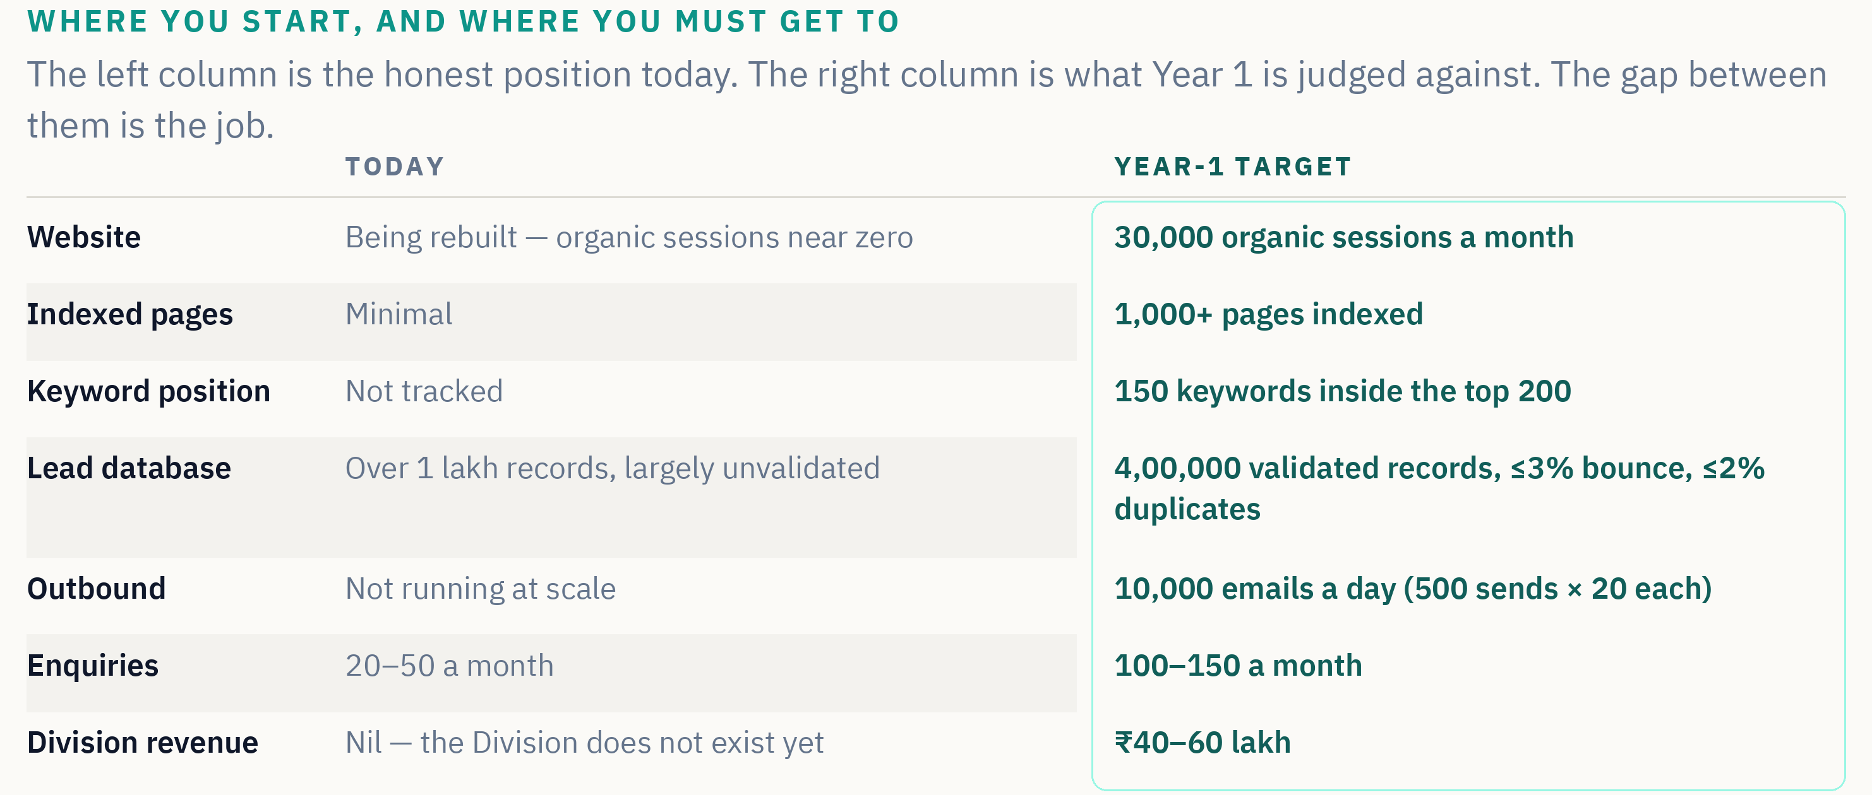
The left column is not flattering and it is not meant to be. Presenting a clean slate would be dishonest, and a partner who arrives expecting one will spend three months discovering otherwise. The gap between the two columns is precisely the job, and hitting the right-hand column is how Year 1 will be judged.

19. What already exists on Day 1
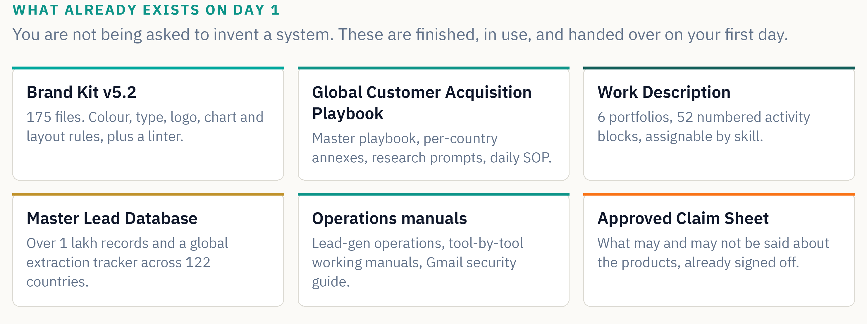
This matters more than it may first appear. The most common way a small team fails at a mandate this size is that it spends its first six months building the scaffolding — deciding on a brand standard, arguing about tools, constructing a process — and runs out of goodwill before it produces anything. That work is already done. You inherit a standard and start producing against it.

20. How four people do agency-scale work
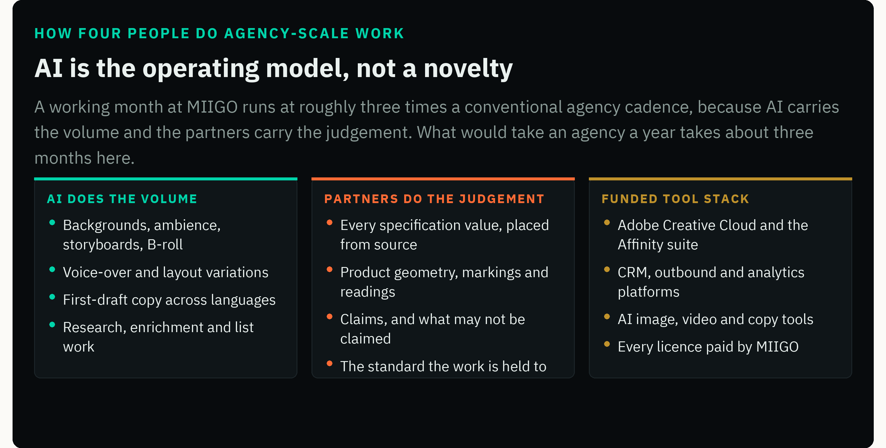
The division of labour is deliberate, and the line is drawn where liability sits. Generative tools may produce backgrounds, ambience, storyboards, B-roll, voice-over and layout variations. They may not produce the logo or the MADE IN BHARAT lockup, product labels, engineering markings, display readings, model numbers, specification figures, connectors or critical geometry, or anything implying a certification.
Every specification value is placed from a controlled source document. Never generated inside an image, never recalled from memory, never inferred from a similar product. A fabricated figure is an automatic fail at assessment stage and a serious matter afterwards.

21. Month one sets the standard
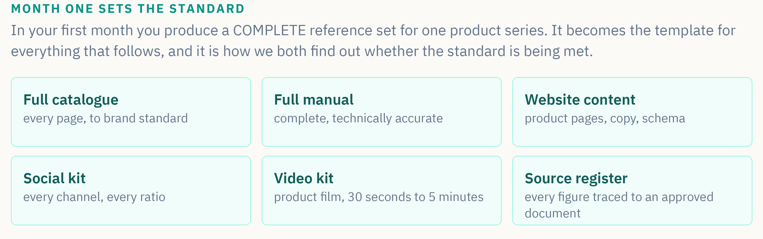
From month two onward the working rhythm is roughly three times a conventional agency cadence: daily social, two to three films a week, three catalogue or manual sections a month. What would take an agency a year takes about three months here — which is what makes covering the full range in Year 1 possible at all.

22. What MIIGO provides, and what you bring
MIIGO provides | You bring
Office space at Pocharam, Hyderabad — rent, power and internet | Your own laptop and phone
Shared accommodation for relocating partners | Your own internet connection
The full tool stack, including Adobe Creative Cloud and the Affinity suite | Skill, judgement and a professional standard
CRM, outbound, analytics and AI platforms, fully licensed | A real commitment of years, not months
Admin, compliance, filings and audit | Willingness to relocate to Hyderabad
The ₹10,000 monthly advance from Day 1 | Absolute discipline on accuracy
Working capital until client money arrives | No capital whatsoever
A guaranteed anchor mandate and a prospective client-development pipeline

Your personal capital at risk is nil. Your laptop, phone and internet are assumed to be things you already own; if that is a genuine obstacle for an otherwise strong candidate, raise it and we will discuss it rather than lose you over hardware.

23. How the Division is governed
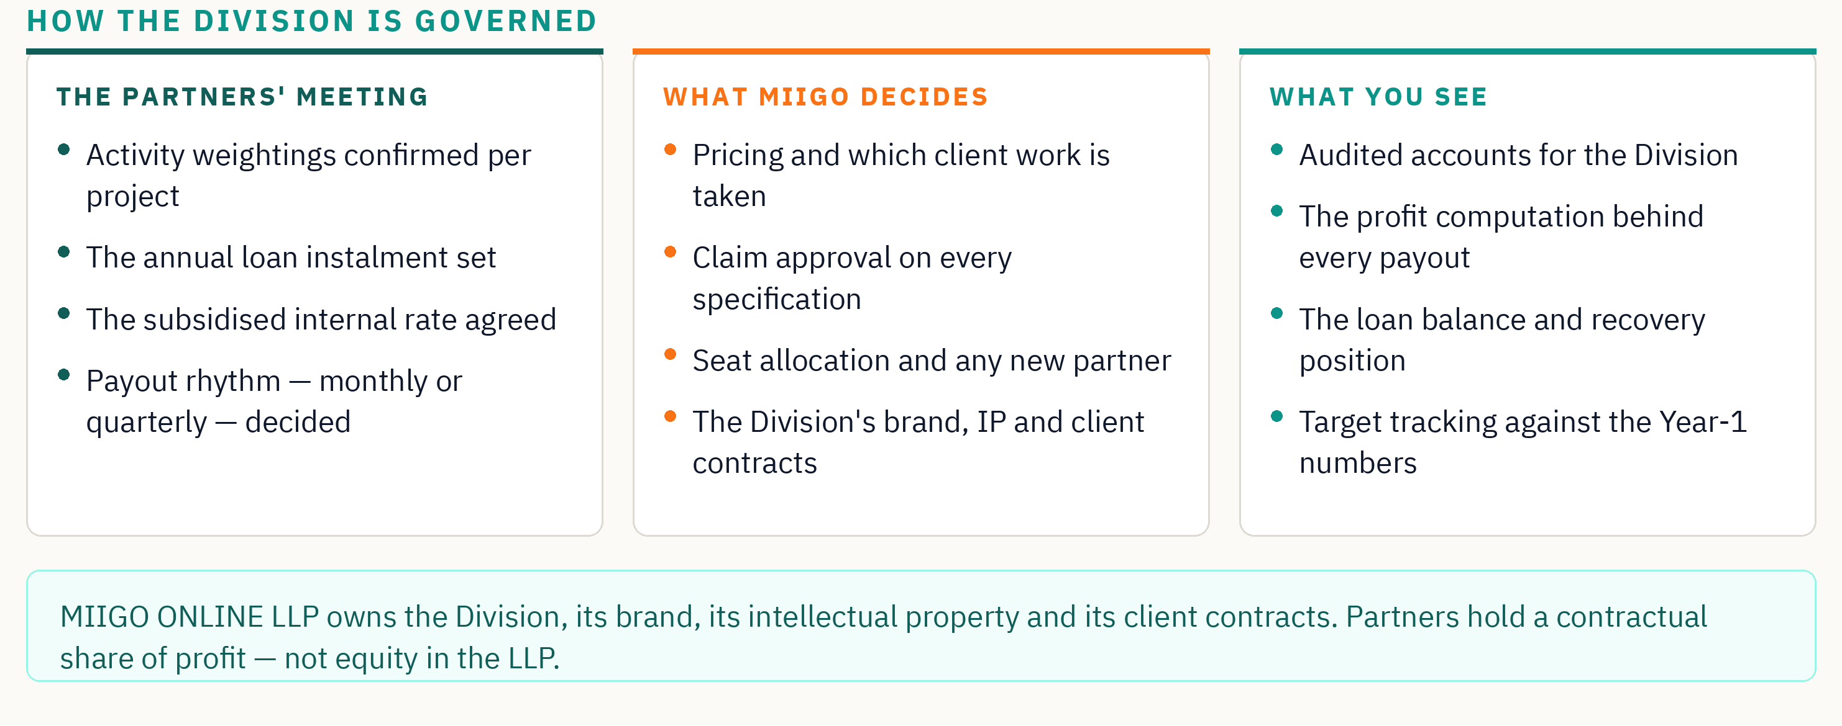
The partners' meeting is where the decisions that affect your income are taken: activity weightings, the annual loan instalment, the subsidised internal rate and the payout rhythm. It is a real forum, and the profit computation behind every payout is shown to the partners rather than announced to them.

Two things we want you to see clearly
MIIGO sits on both sides of several tables. It sets the price it pays for its own work and also takes fifty per cent of the profit on that work. It sets the annual loan instalment and also earns interest on whatever remains unrecovered. Neither arrangement is hidden and neither is unusual for a division funded entirely by its parent — but a partner is entitled to see the structure rather than discover it, and to raise it in the partners' meeting whenever it bites.

24. The commercial terms in full
This section sets out the mechanics that decide what you are paid. It is deliberately dry. Everything persuasive in this document rests on these rules holding, so they are stated in full rather than summarised.
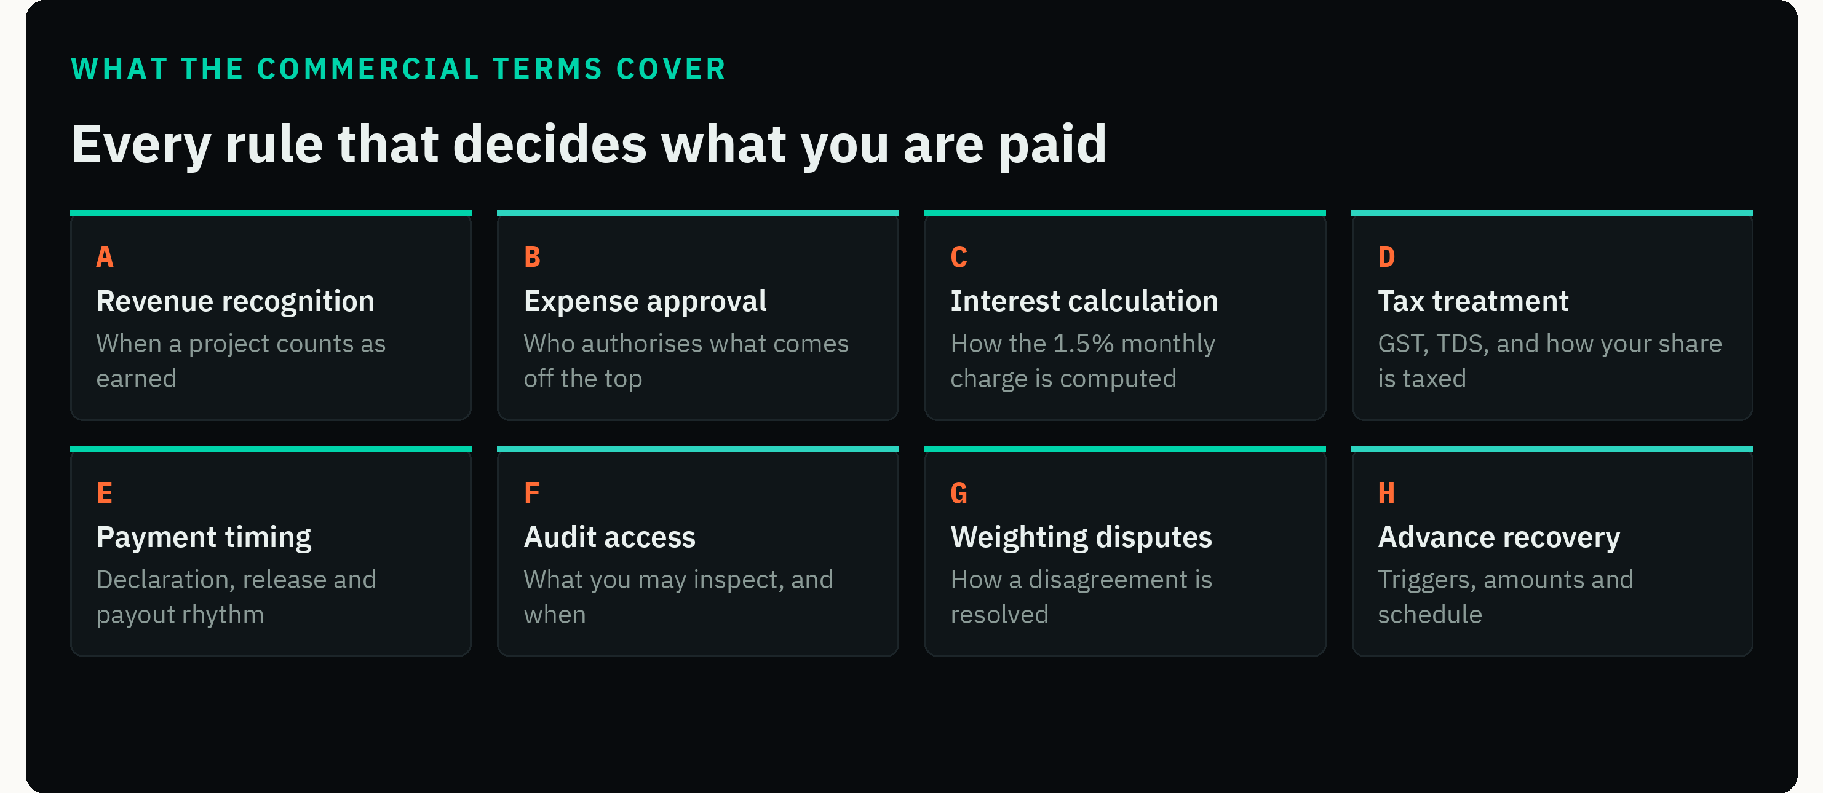

A. Revenue recognition — when a project counts
A project enters the Division's books when the purchase order or written engagement is accepted, valued at the order amount excluding tax. It becomes divisible only when the money is realised: for MIIGO's own work, on the quarterly declaration; for client work, once the client has paid. Part-payments are recognised proportionally, so a half-paid engagement releases half its pool. Unrealised revenue never enters the pool at all — nobody is charged for it and nobody earns from it.

B. Expense approval — what comes off the top
Only actual, documented, project-attributable costs are deducted: media and advertising spend, subcontracted work, licence costs consumed by that project, and travel undertaken for it. Every expense above ₹25,000 requires the Director's written approval before it is incurred. Expenses are recorded against the project, never spread silently across the Division, and the expense ledger for any project is open to every partner who worked on it.
General overheads — office, accommodation, admin, audit — are not charged to individual projects in Year 1. They are carried by MIIGO into the loan. From Year 2 they become ordinary running costs of the Division and are met from its revenue before profit is struck.

C. Interest calculation
Interest accrues at 1.5% per month, compounding monthly, on the outstanding balance of MIIGO's funding — roughly 19.6% a year. It is computed on the balance actually drawn, month by month, not on the full facility. Interest is an expense of the Division and appears in the profit and loss account. Principal recovery is a balance-sheet movement and is never charged as an expense, so it does not reduce the profit partners share. The full amount is intended to clear within three to five years.

D. Tax treatment
All figures in this document are stated excluding GST. The Division raises tax invoices in the name of MIIGO ONLINE LLP and GST is charged, collected and remitted by the LLP; it never forms part of the divisible pool. A partner's profit-share is a payment for professional services and is subject to tax in the partner's own hands, with TDS deducted at the applicable rate at the time of payment and a certificate issued. Each partner is responsible for their own income-tax filing, advance tax and, where their receipts cross the threshold, their own GST registration.
Have this checked
The tax treatment above is set out in good faith and reflects how the Division intends to operate. It is not tax advice. Before signing, have it reviewed by your own chartered accountant — your position depends on your other income, your registration status and rules that change from year to year. MIIGO's own accountant will confirm the Division's side before any agreement is issued.

E. Payment timing
MIIGO's own projects are declared quarterly, within thirty days of each quarter end. Client projects release their pool once the client's payment is realised. Partner payouts run on a monthly or quarterly rhythm, set in the partners' meeting and fixed for a full financial year so it cannot be changed mid-year. The ₹10,000 advance is paid monthly regardless of the payout rhythm and is set off against the share declared.

F. Audit access
The Division operates a separate bank account. Its accounts are audited annually. Every partner may inspect the Division's profit and loss account, the project-level revenue and expense ledger, the computation behind their own payout, the outstanding loan balance and the recovery position to date. Inspection is available on request at any time and is presented to all partners at least once a year.

G. Activity weightings and disputes
Weightings are agreed before a project starts, so the conversation at the end is about which activity blocks were delivered — a question of record, not of feeling. Where a partner disputes a weighting, the sequence is fixed: raise it at the next partners' meeting; if it is not resolved there, the block record and time log are reviewed against the agreed weighting table; if it is still not resolved, the Director decides and records the reason in writing. That decision is final for that project, and the weighting table is amended so the same dispute cannot recur.
We would rather state plainly that the Director holds the casting vote than pretend a four-way partnership never deadlocks. What the process guarantees is that a decision is made, recorded and explained, and that the rule is corrected for next time.

H. The advance, and when it becomes repayable
The ₹10,000 monthly advance is drawn against future profit-share. In the normal course it is simply set off against what you earn and is never repaid in cash.
Trigger | What becomes repayable | How
You stop within twelve months of starting | The full advance drawn to that date | Set off against any declared share; any remainder repayable within 90 days
The partnership ends for sustained performance dissatisfaction | The advance drawn in the preceding six months | Set off first; balance by agreed instalments
You are found to be working against MIIGO's business, directly or indirectly | The full advance drawn, plus any share not yet paid is withheld | Immediately, and the matter passes outside this document
You leave after twelve months in good standing | Nothing | Your declared share to the date of exit is paid in the normal cycle

Where no profit has been declared at the time a trigger occurs, the advance stands as a simple amount due and is recovered on the schedule above rather than from a pool that does not yet exist. Where a partner's share for a year falls below the advance drawn without any trigger event, the shortfall is settled case by case in the partners' meeting.

What this section is, and is not
These terms describe how the Division intends to operate and are stated so you can evaluate the offer properly. They are not the agreement. The signed partnership agreement is the only document that creates binding obligations between you and MIIGO ONLINE LLP, and where it differs from anything here, it governs. Take independent advice on it before you sign — we would think less of a partner who did not.

25. What could go wrong
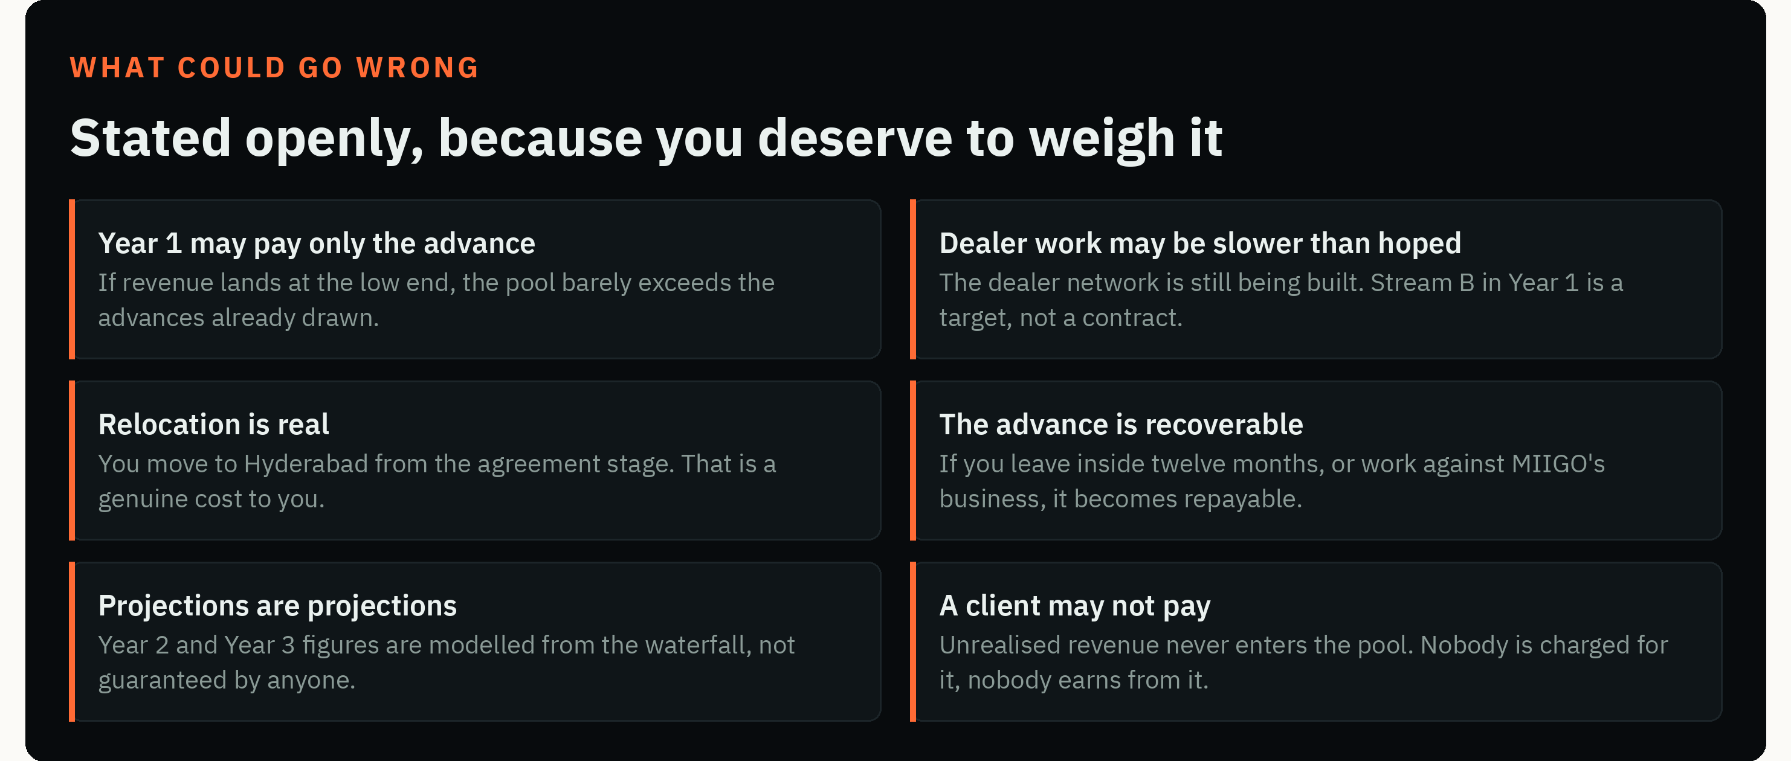
Every one of these is a real possibility rather than a formality. If any of them is unacceptable to you, that is useful information for both of us and it is better surfaced now than in month four.
On relocation, one qualification
If relocation is a genuine obstacle for you rather than a preference, say so rather than withdrawing. We are willing to discuss it, and a workable arrangement will need compromise from both sides. The partners' meeting takes the call on any such arrangement.

26. How we select
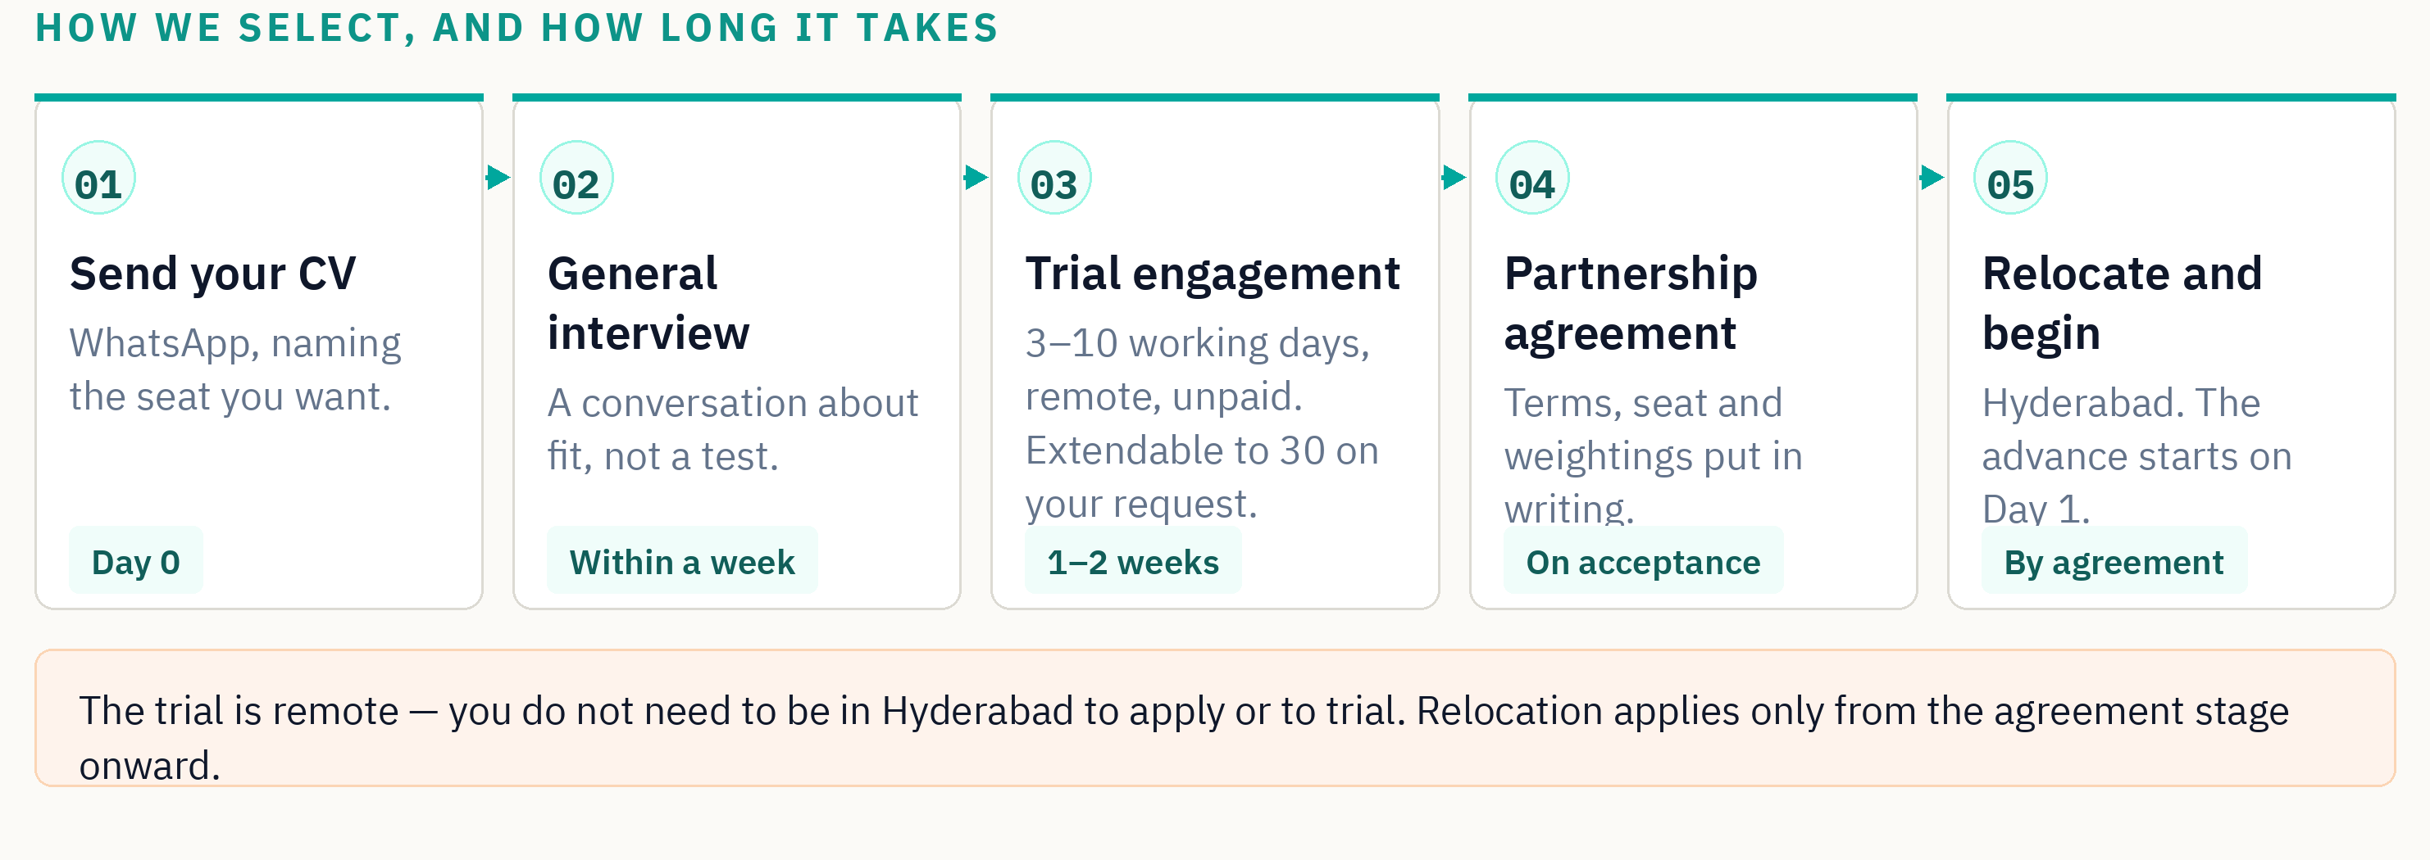

What the trial engagement involves
A short, self-paced practical assignment issued with a real source pack. You work remotely, at your own pace, and report the hours you spent in a short production note. The assignment is scored out of 100 across four capability bands with a minimum in each, and the full scoring breakdown is shown to you before you start — we are not testing whether you can guess what we want.
One rule overrides the scoring entirely: any fabricated specification, figure or claim is an automatic fail regardless of how good the rest of the work is. In this category that is not harshness, it is the whole point.
The trial is unpaid, and we say so plainly. It runs three to ten working days as standard, and can be extended to a maximum of thirty days if you ask for more time.

27. Who you are partnering with
MIIGO ONLINE LLP is led by its Founder and Director, who has twenty-three years in technical sales, calibration and instrumentation, and who runs product development, technical documentation and this Division personally.
He holds the client-facing portfolio — client delivery and account management — himself. He sells; partners deliver. That is not a temporary arrangement while the team finds its feet; it is how the Division is designed to run, and it is why partners are not expected to prospect for their own work.
What partnership means here, precisely
MIIGO ONLINE LLP owns the Digital Marketing Division, its brand, its intellectual property and its client contracts. Partners hold a contractual right to a defined share of profit. This is not equity in the LLP and it does not carry ownership of the company. It is a profit-share partnership, and the agreement you sign will say so in those terms.

28. Questions and answers
Is this employment?
No. It is a partnership with a profit-share. The ₹10,000 monthly advance is an advance against your future profit-share, not a wage.
Do I have to invest any money?
No. MIIGO funds the entire Year-1 cost base. A partner may lend money to the Division if they wish, at the same interest rate MIIGO charges, but nobody is required or expected to and nobody is disadvantaged for declining.
Is the ₹10,000 advance recoverable?
It is drawn against your future profit-share, so in the normal course it is simply set off against what you earn and never repaid in cash. It becomes repayable in three situations. If you stop within twelve months of starting. If the partnership ends because of sustained performance dissatisfaction. If you are found to be working against MIIGO's business by direct or indirect means.
How exactly is the 50% partner pool split between the four of us?
By the activity blocks each partner delivered on that project, using pre-agreed weightings, confirmed in the partners' meeting. It is not an equal four-way split, and a partner carrying more scope earns more.
What if I bring in a client myself?
The 10% business-development commission on the project value, excluding tax, goes to whoever brought the project in — including you. The remaining waterfall then runs as normal, and you also earn from the pool for whatever activity blocks you deliver on that project.
Who owns the client relationship?
MIIGO ONLINE LLP. All client contracts, the Division's brand and its intellectual property belong to the company. Partners hold a contractual profit-share.
What happens if a client does not pay?
That revenue never enters the pool. Nobody is charged for it and nobody earns from it. MIIGO carries the Division's operating losses in the first year only; partners are never asked to underwrite a client's credit risk.
Can I do this remotely, or part-time alongside other work?
The trial engagement is remote. From the agreement stage onward the expectation is Hyderabad, with office and shared accommodation provided at Pocharam. Any remote-working arrangement is a matter for discussion in the partners' meeting; if all partners agree, it is possible.
Why is the interest rate 1.5% a month rather than a bank rate?
Because it is unsecured funding with no collateral, no covenants and no personal guarantee from any partner. A bank would not write it at all. The total interest across the life of the loan is expected to be near ₹9 lakh, of which the partner pool bears half — 50% only, never more.
What if the Division does not work?
MIIGO absorbs the operating loss and the unrecovered loan. You would have earned the advance and lost the time. That is a real cost and we do not pretend otherwise — but it is not a financial loss in the way a failed agency would be.
Can I hold more than one seat?
Yes. Several activity blocks and more than one portfolio can sit with a single partner, and your weighting in the pool reflects the scope you carry.
What happens after Year 3?
The profit-share continues on the same basis with no ceiling. Seats can be extended to six, and delivery is scaled with bench partners, junior staff or freelancers as client work requires.
How do I know the profit figure I am shown is right?
A separate bank account is maintained for the Division. Its accounts are audited, and the profit computation behind every payout is shown to the partners along with the loan balance and the recovery position.
What is the single fastest way to fail this process?
Inventing a specification, a figure or a claim. It is an automatic fail at assessment and it is the one thing this category does not forgive.
What does “long-term association” actually mean? Am I locked in?
No. It describes the intention on both sides, not a legal chain. The honest version is that we are looking for someone who intends to make this their working life, not a stop on the way somewhere else — but nothing binds you to that. You may leave, and the only financial consequence is the advance-recovery rule above if you go inside twelve months. What it means in practice is that we are not looking for someone who plans to test this for a year — the model only pays properly from Year 2 onward, so a short stay costs you more than it costs us.
Can I be removed from the partnership, and on what grounds?
Yes. Sustained performance dissatisfaction, a fabricated claim or specification, or working against MIIGO's business directly or indirectly. Any such decision is taken in the partners' meeting rather than unilaterally, and the reason is put in writing.
What happens to my share if I leave after three years?
You are paid out whatever has been earned and declared up to your exit, including your share of any project already invoiced and realised. You do not carry a continuing share of future profit, because the share attaches to the seat and the work, not to a shareholding.
Can MIIGO change the 50% split later?
The split is written into the partnership agreement. It is not something MIIGO can vary at will, and any change would require agreement in the partners' meeting. Where MIIGO does hold discretion — the subsidised internal rate, the annual loan instalment — that is stated openly in Section 23 rather than hidden in a clause.
What if two partners disagree about activity weightings on a project?
The weightings are agreed before the work starts, so the end-of-project conversation is about which blocks were actually delivered — a question of fact rather than of feeling. Where a genuine dispute remains, the partners' meeting settles it.
When do I get a written agreement?
At the agreement stage, before you relocate and before your first day. It sets out your seat, your activity weightings, the profit-share terms, the advance and the exit provisions. Nobody is asked to move cities on a handshake.
What if MIIGO's own business slows down?
The ₹30 lakh anchor mandate is a committed floor for Year 1 and is not reduced by a slowdown; what a slowdown would affect is the scale above that floor and the pace of Year 2. That is a genuine risk and it is one reason Stream B matters — client revenue is what makes the Division resilient rather than dependent. It is also why client work takes priority once the team is expert.
Can I bring someone from my own network into a seat?
Yes, and we would welcome it. Seat allocation is decided by MIIGO, and any candidate goes through the same interview and trial as everyone else — but a strong referral from a partner carries real weight.
Does the ₹30 lakh include advertising spend?
Yes. Media and paid promotion sit inside the ₹30 lakh, not on top of it, and because media is a pass-through cost it reduces the divisible profit. The split between media and service work is set in the partners' meeting. Section 15 shows what reaches a partner at a low, mid and high media share so you can see the floor rather than a single flattering number.
When does client work start, and when does it take priority?
Stream B opens in Quarter 3 of Year 1 as capacity allows, but it never outranks MIIGO's own work during the first twelve months. From Year 2, once the team is expert and the Division funds itself, client work moves to the front — which matters, because client engagements carry the higher rate.
Am I taxed on my profit-share, and how?
Your share is a payment for professional services, taxable in your own hands, with TDS deducted at the applicable rate and a certificate issued. You are responsible for your own filing and advance tax, and for GST registration if your receipts cross the threshold. Section 24 sets out the treatment; take your own accountant's view before signing.
Can I move to a different seat later, or take on a second one?
Both happen. Seats are portfolios of activity blocks, not fixed job titles, so scope can move as the Division learns where each partner is strongest. Your weighting follows the scope you actually carry.
Who pays for travel to a client, a trade fair or a site visit?
The Division does, as a project or operating expense. Travel undertaken for a client project is an actual expense of that project and comes off before the profit is divided, which means it is shared rather than borne by whoever happened to travel.

29. How to apply
Send your CV over WhatsApp, naming the seat you are applying for — P1 Content and Creative, P2 Web, SEO and AI Search Visibility, P3+P4 Demand Generation and Market Intelligence, or P5 Marketing Operations, CRM and Analytics. If you are strong across two, say which two and why.
Add three or four lines on the most demanding piece of work you have personally produced, and what made it demanding. That single paragraph tells us more than a page of tool logos.
Before you send it, read Section 15 again
Section 15 sets out what Year 1 actually pays. If, having read it, you are still interested, then we are having the right conversation and we would like to hear from you. If it changes your mind, that is a good outcome for both of us and no time has been wasted.

CONTACT
MIIGO ONLINE LLP · Pocharam, Hyderabad, Telangana, India
Applications: CV over WhatsApp to +91 93986 93085, naming your seat.
Detailed capability profiles for each seat, the Work Description and the practical assignment brief are issued after your CV has been reviewed.

This document is confidential. It is issued to a named individual for the purpose of considering a partnership with MIIGO ONLINE LLP and should not be circulated further. This invitation is informational: only the signed partnership agreement creates binding terms between the parties, and where the two differ, the agreement governs. Figures for Year 2 and Year 3, and all performance targets, are projections modelled from the profit waterfall in Section 12 and are not guaranteed. Nothing in this document constitutes an offer of employment. MIIGO ONLINE LLP may revise future issues of this document and holds the right to change or modify its content without any prior notice.

